Project Title: NAWI TASK 5.17 - (Salveson, Andy) Data-Driven Fault Detection and Process Control for Potable Reuse with Reverse Osmosis

**PROGRESS AND STATUS BY SUBTASK:**

# **Task: Task 5.17.1** – Desktop Evaluations

## **Task:** **Subtask 5.17.1.5 –** Data-Driven Model Optimization (DDMO) for Chloramine and Anti-Scalant Dosing

**Subtask Lead: Steve Hayden**

Research Questions:

* How much cost and energy could be saved across the reuse treatment train applying DDMO to adjust the pre-chloramine and antiscalant doses and predict a fault in real-time in response to water quality changes?

**PROGRESS AND STATUS:**

* Collected data from:
  + Las Virgenes Municipal Water District
    - All necessary data is available and shared among the team
  + Orange County Water District
    - All necessary data is available and shared among the team
  + West Basin Municipal Water District
    - Additional data from WBMWD is still needed.

### Budget Spent (YCA)

### Summary

In Task 5.17.1.5, data driven model optimization is used to optimize chemicals dosing for RO membrane system and Title 22 filter. In this report, we update the progresses in the process data analysis for the model creation based on the full-scale plant in OCWD, the pilot plant in LVMWD, and the full-scale plant WBMWD.

OCWD is measuring trace chemicals in the RO feed and permeate by Xact 920, which documents the trace chemicals passage across RO and thus informs the RO membrane scaling for RO stages 1, 2, and 3. We completed data preprocessing including temperature correction and are working on prediction of salt passage in terms of conductivity and the chemical equilibrium concentration polarization using Xact 920 data. The inhibitor (anti-scalant) is subject to optimize to prevent scaling and to maintain RO permeability as well as salt passage.

LVMWD adopts TMG10D RO membranes (Toray), and we completed exchanging data into temperature correction data using Toray’s software to understand the general performance trends. We are working on prediction of water qualities such as conductivity, and TOC. In the model creation, we considered head loss at TO membrane behavior as a function of total chlorine concentration detect. Reduce operating costs by optimizing drive pressure while reducing chlorine dependency.

WBMWD receives secondary effluent from the City of Los Angeles’s Hyperion Water Reclamation Plant to produce recycled water for industrial, irrigation, and boiler feed. We received data from WBMWD and completed data preprocessing. In this analysis, we are working on data analysis focusing on effluent turbidity against Title 22 criteria from the Title 22 filter and ferric chloride and cationic polymer are subject to optimize to save chemical dosage.

### Desktop Evaluation based on OCWD

#### RO Optimization Overview

* RO Optimization Overview for OCWD

Basic optimization story for OCWD is to decrease the chemical dosing cost (e.g., sulfuric acid or inhibitor) while satisfying water quality standards or monitoring a RO membrane scaling.

RO optimization is to improve the operation in some period of time. This type of optimization problem is the scheduling problem, which is formulated and solved according to procedure as shown in Figure 1.1. The procedure consists of drawing flow chart, formulation optimization problem, and calculation operational schedule. Therefore, first and second are required to construct a simulation model.

* Flow Chart

Figure 1.2 shows the flow chart for OCWD based on the RO system configuration. The RO system configuration and tag name list of OCWD is provided as “Additional Materials A1” at the end of this report. Figure 1.2 (a) is the flow chart limited to the part related to permeate TOC prediction and Figure 1.2 (b) is the flow chart limited to the part related to permeate EC prediction.

In Figure 1.2, arrows connecting objects are assigned variables. The classification of each variable (e.g., optimization variable or fixed variable) is described below. The storage object means exogenous variable, the hexagon object means mathematical model, and the square object means predictive variable (e.g., water quality data). The arrow toward the object is input data and the arrow out from the object is output data. The color of arrows is different for each object to which it is connected. Especially, mathematical models have both input and output data. Output data from the hexagon object toward the square object is calculated by the prediction model in the later section.



**Figure 1.1: Procedure for Solving Scheduling Problem**



1. **RO Total Flow Chart (Permeate TOC)**



1. **RO Each Stage Flow Chart (Permeate EC)**

**Figure 1.2: Flow Chart for RO Optimization Simulation (OCWD)**

* Formulation Optimization Problem

The optimization problem is formulated as minimizing objective function satisfying constraints. In the optimization problem, $x$ denotes the optimization variable and $f$ denotes the objective function (cost function). A detail of the problem is provided at the next section.

Table 1.1 shows the optimization variable list in the OCWD optimization model. “Optimization Variable” means cost or manipulated variable (chemical dose), “Fixed Parameter” is given by actual value, “Intermediate Variable” indirectly affects the objective function or constraints in the calculation. In OCWD optimization model, the optimization variable is sulfuric acid and threshold inhibitor usage, and the intermediate variables are the permeate electric conductivity (EC) at stage 1, stage 2, and stage 3, and permeate TOC calculated by water quality prediction model.

**Table 1.1: Optimization Variable List (OCWD)**

|  |  |  |  |
| --- | --- | --- | --- |
| ID No. | Description | Unit | Opt. Variable / Fixed Parameter |
| ID0000 | Sulfuric Acid Usage | ton/day | Optimization Variable |
| ID0001 | Threshold Inhibitor Usage | ton/day | Optimization Variable |
| ID0002 | Feed EC | $$μS/cm$$ | Fixed Parameter |
| ID0003 | Feed TOC | ppm | Fixed Parameter |
| ID0004 | Feed Temperature | $$℉$$ | Fixed Parameter |
| ID0005 | Feed pH | - | Fixed Parameter |
| ID0100 | Stage 1 Feed Pressure | psi | Fixed Parameter |
| ID0101 | Stage 1 Feed Flow Rate | gpm | Fixed Parameter |
| ID0102 | Stage 1 Permeate Flow Rate | gpm | Fixed Parameter |
| ID0200 | Stage 2 Feed Pressure | psi | Fixed Parameter |
| ID0201 | Stage 2 Feed Flow Rate | gpm | Fixed Parameter |
| ID0202 | Stage 2 Permeate Flow Rate | gpm | Fixed Parameter |
| ID0300 | Stage 3 Feed Flow Rate | gpm | Fixed Parameter |
| ID1000 | Stage 1 Permeate EC | $$μS/cm$$ | Intermediate Variable |
| ID2000 | Stage 2 Feed EC | $$μS/cm$$ | Intermediate Variable |
| ID2001 | Stage 2 Permeate EC |  | Intermediate Variable |
| ID3000 | Stage 3 Feed EC | $$μS/cm$$ | Intermediate Variable |
| ID3001 | Stage 3 Permeate EC | $$μS/cm$$ | Intermediate Variable |
| ID4000 | Permeate TOC | ppm | Intermediate Variable |

#### RO Optimization Simulation Model

* Summary

We formulated RO optimization problem for OCWD and constructed a RO optimization simulation model implemented by the water quality prediction. We will introduce the scaling model and carry out the optimization simulation and calculate an improvement effect compared actual operation in the past period in the final report.

* Mathematical Optimization Problem

RO optimization problem is formulated as the scheduling problem. The operational schedule structure is shown as Table 1.2. $x_{i}\left[t\right]$ denotes the $i$-th variable schedule at time $t$, $x_{i}=(x_{i}\left[1\right], x_{i}\left[2\right],…, x_{i}\left[L\right])$ denotes the $i$-th variable schedule in all period, $X=(x_{1},x_{2},…,x_{n})$ denotes all variables schedule in all period, $L$ denotes the length (step size) of the optimization period, and $n$ denotes the number of variables, respectively. For example, if the optimization period is 1 week of 30 minutes time interval data (e.g., 0:30, 1:00. 1:30, 2:00, …), we can estimate $L=(60[minutes]/30)×24[hours]×7[days]=336$ step.

The objective function is sum of the threshold inhibitor usage and sulfuric acid usage during the optimization period. The constraint conditions are given by lower and upper limit, and water quality standards limit based on Logarithmic Reduction Value (LRV). Table 1.3 shows only the major constraints. LRV $γ_{X}$ of water quality data $X$ (e.g., electric conductivity and TOC) as follows:

$$\begin{aligned}γ_{X}\left[t\right]=\log_{10}\left(\frac{X_{feed}[t]}{X_{perm}[t]}\right); t=1,2,…,L\#\left(1.1\right)\end{aligned}$$

Here, $X_{feed}$ denotes feed quality data $X$ and $X_{perm}$ denotes permeate quality data $X$ at each stage. The detail of the problem formulation is provided as “Additional Materials A2” at the end of this report.

The scale of the above problem can be roughly estimated such as number of total optimization variables and number of total constraints $K=12L-2$. For example, if the optimization period is 1week of 30 minutes time interval data, we can estimate $L=(60/30)×24×7=336$ steps, $N=2×336=672$, and $K=12×336-2=4030$.

**Table 1.2: Operational Schedule Structure**

|  |  |  |  |  |
| --- | --- | --- | --- | --- |
|  | $$x_{1}[t]$$ | $$x_{2}[t]$$ | $$⋯$$ | $$x_{n}[t]$$ |
| $$t=1$$ | $$x_{1}[1]$$ | $$x_{2}[1]$$ | $$⋯$$ | $$x_{n}[1]$$ |
| $$t=2$$ | $$x_{1}[2]$$ | $$x_{2}[2]$$ | $$⋯$$ | $$x_{n}[2]$$ |
| $$⋯$$ | $$⋯$$ | $$⋯$$ | $$⋯$$ | $$⋯$$ |
| $$t=L$$ | $$x_{1}[L]$$ | $$x_{2}[L]$$ | $$⋯$$ | $$x_{n}[L]$$ |
|  |  |  |  |  |

**Table 1.3: Major Constraints (upper/lower limit and LRV)**

|  |  |  |  |
| --- | --- | --- | --- |
| **Description** | **Units** | **Lower** | **Upper** |
| Stage 1 Permeate EC | $$μS/cm$$ | 10 | 95 |
| Stage 2 Permeate EC | $$μS/cm$$ | 20 | 200 |
| Stage 3 Permeate EC | $$μS/cm$$ | 60 | 350 |
| Permeate TOC | ppm | 0 | 0.15 |
| Stage 1 Permeate EC LRV | - | 1.5 | 2.3 |
| Stage 2 Permeate EC LRV | - | 1.5 | 2.3 |
| Stage 3 Permeate EC LRV | - | 1.5 | 2.3 |
| Permeate TOC LRV | - | 1.5 | 2.5 |

* Optimization Algorithm

The above problem is classified as constrained and black-box problem. We constructed and used an optimization algorithm by combining SHADE[1] and Feasibility Rule[2] for solving the problem. SHADE is known to the best unconstrained black-box optimization in the optimization field recently and often used in the BBOB competition[3]. Feasibility Rule is one of the constraint handling techniques, which enable unconstrained optimization algorithms to apply to the constrained optimization. We finished to write python source code from scratch and will apply it to the above problem.

#### Water Quality Prediction

We received data measured at 30-minute intervals in RO B01 unit from OCWD. The RO system configuration of OCWD is provided as “Additional Materials A1” at the end of this report. The focus of the analysis is to create statistical prediction models for RO permeate electric conductivity (EC) and TOC, which are considered an indicator of RO membrane scaling. Each permeate EC is measured at each stage permeate in B01 unit and permeate TOC is measured at the whole RO permeate.

* Data Preprocessing

We used continuous data from May 13th, 2022 to November 18th, 2022 and excluded data from other periods because it contains data that is not properly measured or has significantly different trends.

There are many noise components in the received raw data. The data preprocessing for them was needed before data analysis. Figure 1.3 shows a summary diagram of the data preprocessing, which consists of. The flow chart in Figure 1.3 explains the data preprocessing approach including the outlier filtering, the noisy data imputation, and the missing data imputation. The outlier filtering is to remove outlier data by imposing upper-lower bounds as a first step. The noisy data imputation is to replace noisy data with alternative data in the time series data by using Hample filter with 96 window steps. Hample filter detects data points exceeding confidence interval in a given windows as noisey data and replaces them with the median value in the given windows as alternative data. The missing data imputation is to fill missing raw data by copying previous and next actual data.

We converted the daily chemical dosing usage data with total daily interval into 30-minute usageinterval data by dividing the amount by 48 [steps].

The raw and preprocessed trends of Permeate EC [μS/cm] at each stage and permeate TOC from May 2022 to November 2022 are plotted with raw data and the preprocessed in Figure 1.4 (a)-(h). By preprocessing the data, outliers are removed, and the data behavior can be extracted.

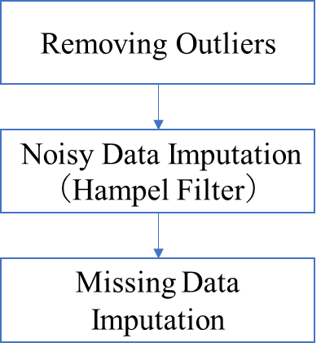

**Figure 1.3: Data Preprocessing Flow Chart (OCWD)**

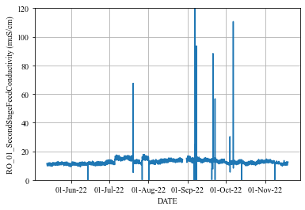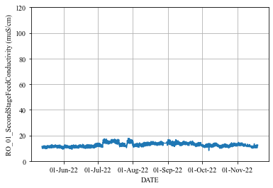

**(a): 1st Stage Raw Conductivity (b): 1st Stage Preprocessed Conductivity**

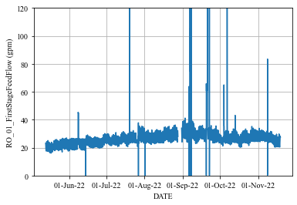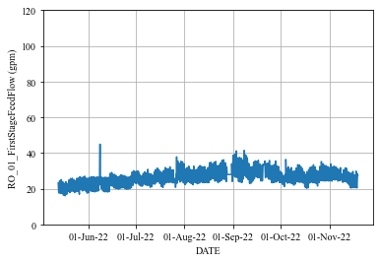

**(c): 2nd Stage Raw Conductivity (d): 2nd Stage Preprocessed Conductivity**

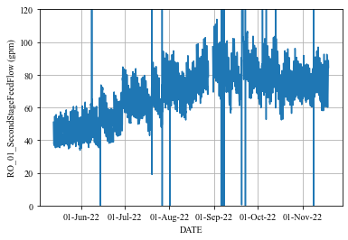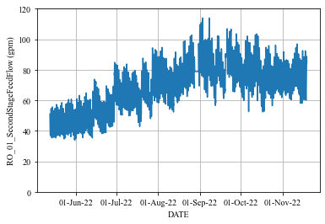

**(e): 3rd Stage Raw Conductivity (f): 3rd Stage Preprocessed Conductivity**



**(g): Permeate Raw TOC (h): Permeate Preprocessed TOC**

**Figure 1.4: Raw and Preprocessed Data of Permeate Conductivity in Each RO Stage and Permeate TOC (OCWD)**

* Mathematical Model for Water Quality Prediction

We constructed four models for permeate ECs at 1st, 2nd, and 3rd stages and permeate TOC at the whole RO. The prediction models are based on the multiple linear regression (MLR), which is a statistical model. The mathematical model of MLR is given as follows:

$$\begin{aligned}y=w_{1}x_{1}+w_{2}x_{2}+…+w_{M}x_{M}+w_{0}\#\left(1.2\right)\end{aligned}$$

Here, $x_{j}$ ($j=1,2,…,M$) denotes explanatory variable, $y$ denotes predictive variable, $w_{j}$ ($j=1,2,…,M$) denotes coefficient parameter, and $w_{0}$ denotes bias parameter. The parameters $w_{j}$ and the standardized coefficients are estimated by actual data in the training period. The standardized coefficients can be interpreted as relative contribution of each variable $x_{j}$ for prediction of $y$. The detail of the estimation of the parameters is provided as “Additional Materials A3” at the end of this report.

Table 1.4 shows the variable list for each water quality prediction model. “X” means explanatory variable, “Y” means predictive variable, and “*” means calculated variable. Tag name list is provided as “Additional Materials A1” at the end of this report.

The calculated 1st stage feed flow rate $Q_{1, feed}$, 2nd stage feed flow rate $Q_{2, feed}$, and 3rd stage feed flow rate $Q_{3, feed}$ are given, respectively, as follows:

$$\begin{aligned}Q_{1, feed }=Q_{1, perm}+Q_{2, perm}+Q_{3, perm}+Q_{3, conc}\#\left(1.3\right)\end{aligned}$$

$$\begin{aligned}Q_{2, feed }=Q_{1, feed }-Q_{1,perm}\#\left(1.4\right)\end{aligned}$$

$$\begin{aligned}Q_{3, feed }=Q_{2, feed }-Q_{2, perm }\#\left(1.5\right)\end{aligned}$$

Here, $Q_{i, perm} and Q_{i, conc}$ denote permeate and concentrate flow rates at stages $i=1,2,3$.

The 2nd stage feed EC ${EC}_{2, feed}$ and 3rd stage feed EC ${EC}_{3, feed}$ are calculated based on the law of conservation of mass using the following equations:

$$\begin{aligned}{EC}_{2, feed}=\frac{Q_{1, feed}×{EC}_{1, feed}+Q_{1, perm}×{EC}_{1, perm}}{Q_{1, feed}-Q_{1, perm}}\#\left(1.6\right)\end{aligned}$$

$$\begin{aligned}{EC}_{3, feed }=\frac{Q_{2, feed}×{EC}_{2, feed}+Q_{2, perm}×{EC}_{2, perm}}{Q_{2, feed}-Q_{2, perm}}\#\left(1.7\right)\end{aligned}$$

In the optimization phase, we need to predict permeate ECs (${EC}_{1, perm} and{EC}_{2, perm}$) by the prediction models, which use feed ECs as explanatory variables. Unmeasured feed ECs (${EC}_{2, feed} and{EC}_{3, feed}$) are calculated by Equations (1.5) and (1.6).

**Table 1.4: Variable List in Water Quality Prediction Model (OCWD)**

|  |  |  |  |  |
| --- | --- | --- | --- | --- |
| Variable Name | Stage1 Permeate EC | Stage2 Permeate EC | Stage3 Permeate EC | Permeate TOC |
| RO B01 Feed Pressure | X |  |  | X |
| RO Feed EC | X |  |  | X |
| RO Feed Flow Rate * | X |  |  | X |
| RO Feed Temperature | X | X | X | X |
| RO Feed pH | X |  |  | X |
| Sulfuric Acid Usage | X | X | X | X |
| Threshold Inhibitor Usage | X | X | X | X |
| RO B01 Stage 2 Feed Pressure |  | X |  | X |
| RO B01 Stage 2 Feed EC * |  | X |  |  |
| RO B01 Stage 2 Feed Flow Rate * |  | X |  |  |
| RO B01 Stage 3 Feed EC * |  |  | X |  |
| RO B01 Stage 3 Feed Flow Rate * |  |  | X |  |
| RO Feed TOC |  |  |  | X |
| RO B01 Stage 1 Permeate EC | Y |  |  |  |
| RO B01 Stage 2 Permeate EC |  | Y |  |  |
| RO B01 Stage 3 Permeate EC |  |  | Y |  |
| RO Permeate TOC |  |  |  | Y |

* Training and Period Term

We evaluated the accuracy of prediction models using the data from May 2022 to November 2022 sequentially. Figure 1.5 shows overview of sequential prediction and Table 1.5 shows training and prediction periods in each term.

For example, we trained a model with data from May 13th to May 19th, 2022 (1 week) and tested it against data from May 20th to May 27th, 2022 (1 week) in the first term. In the next term, we slide these periods to 1week later and conduct re-training (model re-tuning). The size of training data set is $2 [points/hour]×24 [hours/day]×7 [days]=336 [points]$ and the size of prediction data set is also $2×24×7=336$ for each term.

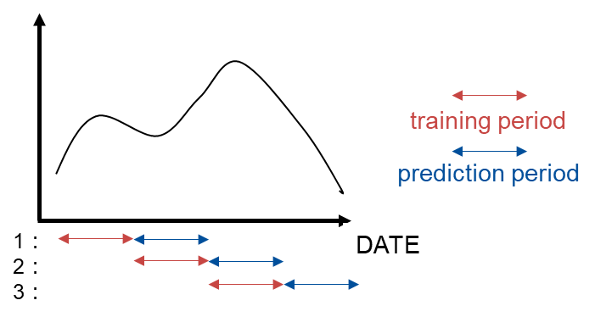

**Figure 1.5: Overview of Sequential Prediction**

**Table 1.5: Training and Prediction Period in Each Term**

|  |  |  |
| --- | --- | --- |
| **Term** | **Trainig Period** | **Prediction Period** |
| 1 | from May 13th to May 19th, 2022 | from May 20th to May 26th, 2022 |
| 2 | from May 20th to May 26th, 2022 | from May 27th to Jun. 2nd, 2022 |
| $$⋮$$ | $$⋮$$ | $$⋮$$ |
| 27 | from Oct. 28th to Nov. 3rd, 2022 | from Nov. 4th to Nov. 10th, 2022 |
| 28 | from Nov. 4th to Nov. 10th, 2022 | from Nov. 11th to Nov. 17th, 2022 |

* Prediction Evaluation Index

The evaluation indexes are Mean Absolute Percentage Error (MAPE) $E_{MAPE}$ [%] and Root Mean Percentage Error (RMSE) $E_{RMSE}$. MAPE indicates a relative prediction error and RMSE is an absolute prediction error. They are calculated between actual data and predicted data in the prediction period. Their mathematical definition is provided as “Additional Materials A3” at the end of this report. Outlier data was excluded from evaluation data in the data preprocessing.

* Predicton Result

Table 1.4 shows prediction accuracy result, Figure 1.6 shows each stage permeate EC and TOC prediction trend charts in the whole priod, and Figure 1.7 shows an enlarged portion of Figure 1.6 from 10th to 16th June 2022 as an example. In Figures 1.6 and 1.7, blue line is preprocessed actual data and red line is prediction data.

Figure 1.6 shows that the sequential prediction can predict global trend with good accuracy. Figure 1.7 shows that the model also can predict periodic fluctuations of EC.

The gray region in Figure 1.6 (a) indicates sudden changes of 1st stage permeate EC actual data between 11 to 15 uS/cm in the period from July to August 2022. The accuracy of sequential prediction during this period is worse because data characteristics differ significantly between training and prediction periods due to those sudden changes.

**Table 1.4: Prediction Accuracy Result (OCWD)**

|  |  |  |  |  |
| --- | --- | --- | --- | --- |
| **Index** | **Stage1 Permeate EC** | **Stage2 Permeate EC** | **Stage3 Permeate EC** | **Permeate TOC** |
| **RMSE** | 2.28 [uS/cm] | 6.26 [uS/cm] | 15.25 [uS/cm] | 0.014 [ppm] |
| **MAPE** | 10.33 [%] | 13.40 [%] | 15.59 [%] | 12.75 [%] |



**(a): 1st Stage Permeate Conductivity**

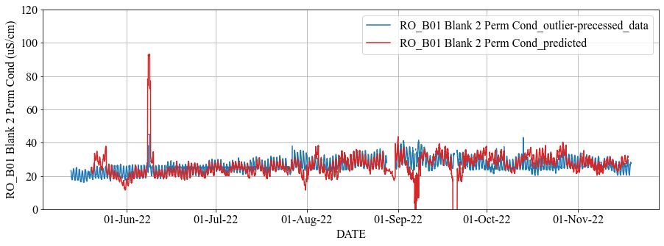

**(b): 2nd Stage Permeate Conductivity**

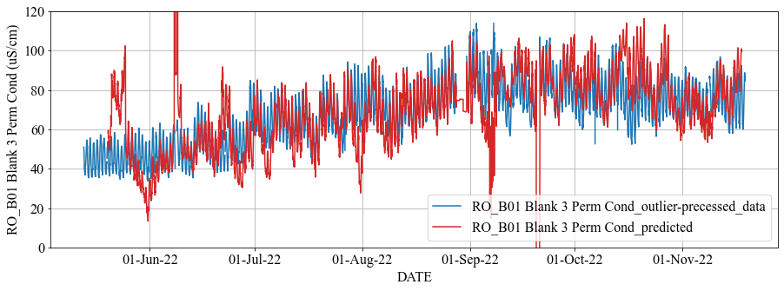

**(c): 3rd Stage Permeate Conductivity**

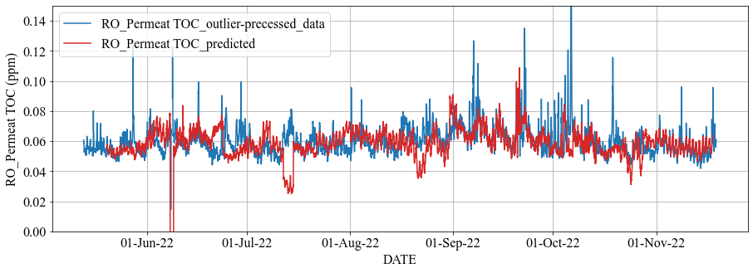

**(d): Permeate TOC**

**Figure 1.6: Prediction Trend in All Period (OCWD)**

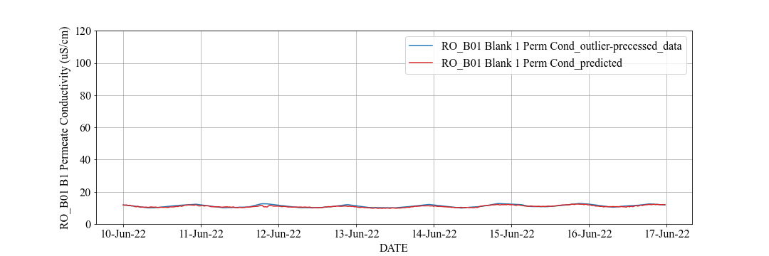

**(a): 1st Stage Permeate Conductivity**

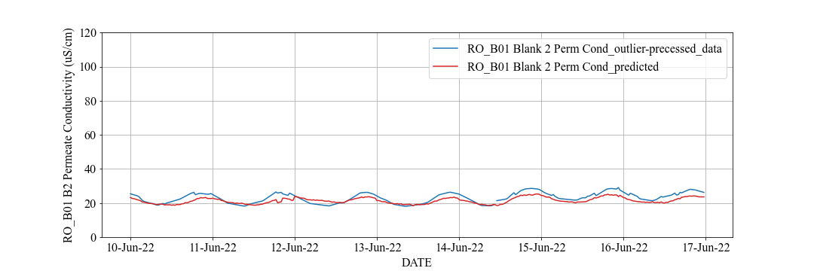

**(b): 2nd Stage Permeate Conductivity**

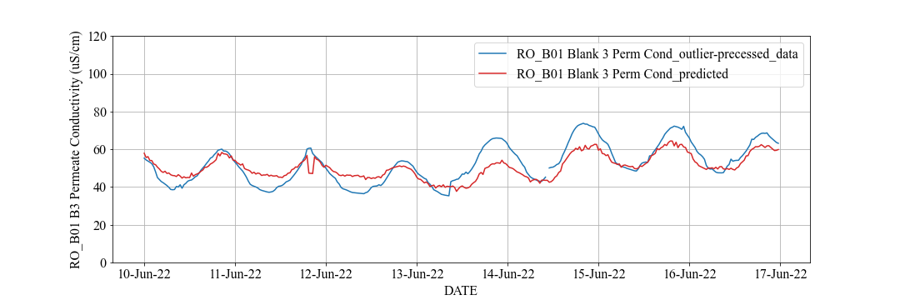

**(c): 3rd Stage Permeate Conductivity**

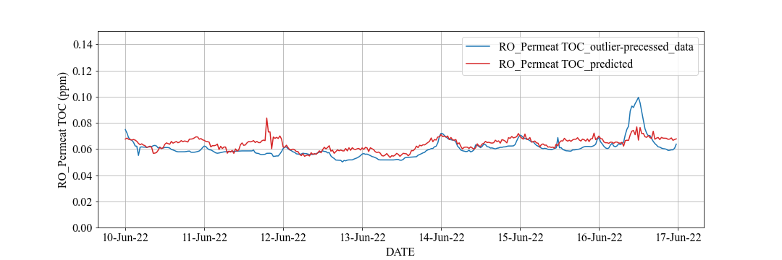

**(d): Permeate TOC**

**Figure 1.7: Prediction Trend from 10th to 16th June 2022 (OCWD)**

Figure 1.8 shows each standard coefficient trend chart of 1st stage permeate EC and TOC prediction model, which is calculated by using Equation (A4.3). In Figure 1.8, the thorizontal axis is start date of each term (1week) in sequential prediction and each color coressponds to coefficient of each explanatory variable. They are relative contribution of each variable for prediction.

In Figure 1.8, the coefficient of RO feed EC (orange line in Figure 1.8 (a)) and RO feed TOC (orange line in Figure 1.8 (b)) are positive and large value in all period. Therefore, feed EC has a significant impact on permeate EC prediction and feed TOC has a significant impact on permeate TOC prediction based on MLR.

On the oher hand, the coefficients of feed flow rate (gray line in Figure 1.8 (a) and yellow line in Figure 1.8 (b)) and feed pH (light blue line in Figure 1.8 (a) and green line in Figure 1.8 (b)) are very small in all period. Therefore, feed flow rate and feed pH has little impact on permeate EC and TOC prediction based on MLR.

Figure 1.9 shows feed flow rate and feed pH actual data trend chart in the all period. Feed flow rate is constant at 4080 [gpm] and feed pH is constant at 6.9. For this reason, they have little impact on permeate EC and TOC prediction.

Moreover, the gray region in Figure 1.8 (a) coressponds to July 2022. The coefficients of sulfuric acid usage (green line) and inhibitor usage (navy blue line) change in the range -0.5 to 0.5 in the period except for the gray region while they significally change in the gray region. This result explains that 1st permeate EC prediction performance deteriorates in the gray region in the Figure 1.6 (a).



**(a): 1st Stage Permeate Conductivity**

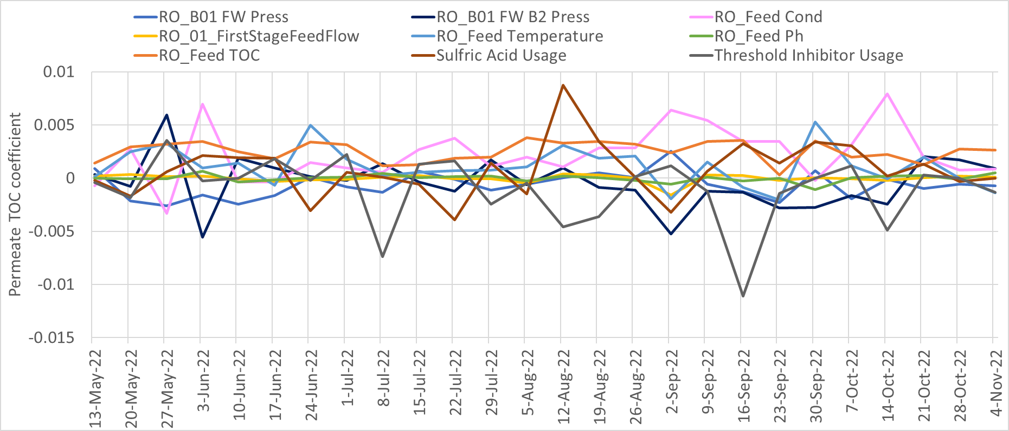

**(b): Permeate TOC**

**Figure 1.8: Standard Coefficients of Prediction Model Trend in All Period (OCWD)**

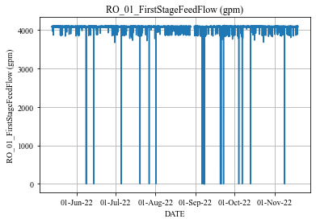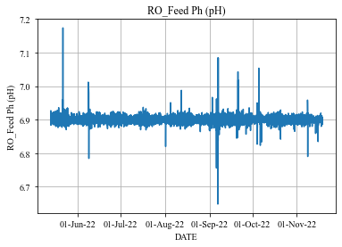

**(a): 1st Stage Feed Flow Rate (b): Feed pH**

**Figure 1.9: Actual Data Trend in RO Feed (OCWD)**

* Future Task

From the results, the sequential prediction based on MLR can predict global trends during most of the period with good accuracy but cannot predict a significant change enough during such as the gray region in Figure 1.6 (a).

From Figure 1.8 (a), the coefficients of the optimization variable (e.g., sulfuric acid usage and threshold inhibitor usage) are small and its positive and negative values are reversed depending on the period. This has negative effects on RO optimization simulation. We should improve the relationship between the chemical dosing and water quality in the prediction model by selecting the specific training period or applying appropriate data preprocessing.

Moreover, sometimes there are sudden and significant changes in prediction value in Figure 1.6. To deal with this, it is considered their values are corrected to the appropriate range (e.g., confidence interval) after MLR based prediction.

#### RO Membrane Scaling using Xact Data

* Summary

We will estimate the potential of scaling by analyzing the concentration of minerals at the surface of RO membranes and solubility of them. The concentration at the surface is generally different from that of the feed water due to concentration gradient around the interface between a membrane and solution caused by selective transfer of water and solutes. This is called as concentration polarization.

The optimal amount of chemical dosing can be calculated by comparing the solubility and concentration at the surface of the membrane. The method to calculate the concentration polarization is described in this report.

* Method to Calculate Concentration Polarization

To derive concentration polarization model, let $C_{i,j,m}$ be a concentration of solute $m$ at each location and stage, and subscripts “ $i,j,m$” denotes RO stage number (1st, 2nd, 3rd stage), locations (feed, membrane surface, permeate, and brine), and solute type.

Considered concentration polarization, the concentration $C_{i,memb,m}$ at the membrane surface is calculated by the following equations. $$\begin{aligned}C_{i,memb,m}=\left(C_{i,brine,m}-C_{i,perm,m}\right)×e^{\frac{{J_{V}}_{solv_{i}}}{k_{i,m}}}+C_{i,perm,m}\#\left(1.8\right)\end{aligned}$$

, where ${J_{v}}_{solv_{i}}$ denotes the permeate flux of solvent and $k_{i,m}$ denotes the mass transfer coefficients. $k_{i,m}$ depends on the permeate fluxes ${J_{v}}_{solv_{i}},{J_{v}}_{salt_{i,m}}$, where ${J_{v}}_{salt_{i,m}}$ denotes permeate flux of solute $m$.

The concentration at unmeasured points is calculated by the following equation:

$$\begin{aligned}C_{i,j,m}={Xact}_{feed,m}*\frac{ EC_{i,j}}{EC_{1,feed}}\#\left(1.9\right)\end{aligned}$$

, where $EC_{i,j}$ denotes electric conductivity at $i$-th stage and location $j$, and ${Xact}_{feed,m}$ denotes solutes data measured by Xact at feed to the 1st stage. The concentration of the feed to the 1st stage and those of the permeate from all stages are measured by Xact. The electric conductivities ${EC}_{i,brine}$ at unmeasured points are calculated by Figure 1.10. A detailed derivation of concentration polarization is provided as “Additional Materials A3” at the end of this report.

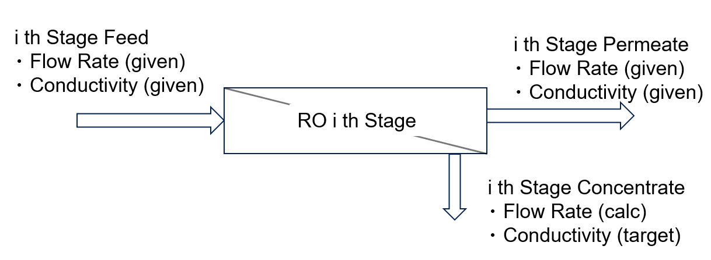

**Figure 1.10: Flow Rates and Conductivities From / To Each Stage**

* Results

The membrane surface concentration calculated by Equations (1.8), (1.9) is shown in Figure 1.11. Figure 1.11 (a) shows the membrane surface concentration of Si and Figure 1.11 (b) shows that of Ca. The left axis is for the 1st stage concentration and the right is for the 3rd. The result shows that the concentration process can be simulated where the salts are concentrated with each stage.in the following two aspects: i) for each stage, salts are about 150 to 200% concentrated at membrane surface (solid line) compared to feed (dashed line); ii) The concentration at the 3rd stage (blue line) is higher than the 1st (orange line).

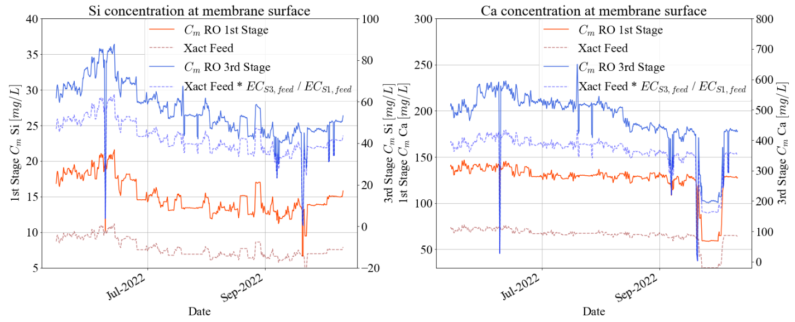

**(a): Si concentration (b): Ca concentration**

**Figure 1.11: Comparison of Concentrations Between Feed and Membrane Surface**

**(The 1st and 3rd Stages Are Plotted)**

* Future Work

The goal of this study is to provide guidance of the amount of anti-scalant dosing. To archive that, we will use the estimated concentration at the membrane surfaces to decide if minerals (mainly Si and Ca) will deposit on the membrane surface considering solubility equilibrium. We will use specialized software[4] to calculate the solubility of minerals at the typical form of the equilibrium equation. For example, the equilibrium equation for calcium sulfate, the cause of scaling, is as follows. $$\begin{aligned} CaSO_{4}↔Ca^{2+}+SO_{4}^{2-}\#\left(1.10\right)\end{aligned}$$

The final outcome will be a model to calculate the optimal amount of anti-scalant considering the concentration and solubility.

### Desktop Evaluation based on LVMWD

#### RO Optimization Overview

* RO Optimization Overview for LVMWD

Basic optimization story for LVMWD is to decrease the chemical dosing cost (e.g., chloramines) while satisfying water quality standards or monitoring a RO membrane fouling. The problem is formulated as scheduling problem same as OCWD.

* Flow Chart

Figure 2.1 shows the flow chart for LVMWD based on the RO system configuration. The RO system configuration and tag name list of LVMWD is provided as “Additional Materials A1” at the end of this report. Figure 2.1 (a) is the flow chart limited to the part related to permeate TOC prediction and Figure 2.1 (b) is the flow chart limited to the part related to permeate EC prediction.

In Figure 2.1, the arrows and objects are same meaning as the case of OCWD (in Figure 1.2). Especially, output data from the hexagon object toward the square object is calculated by the prediction model in the later section.

* Formulation Optimization Problem

Table2.1 shows the optimization variable list in the LVMWD optimization model. “Optimization Variable”, “Fixed Parameter”, and “Intermediate Variable” have the same meaning as in the case of OCWD. In LVMWD optimization model, the optimization variable is UF filtrate total chlorine, and the intermediate variables are the permeate electric conductivity (EC) at stage 1, stage 2, and stage 3, and permeate TOC calculated by water quality prediction model.



1. **RO Total Flow Chart (Permeate TOC)**



1. **RO Each Stage Flow Chart (Permeate EC)**

**Figure 2.1: Flow Chart for RO Optimization Simulation (LVMWD)**

**Table 2.1: Optimization Variable List (LVMWD)**

|  |  |  |  |
| --- | --- | --- | --- |
| ID No. | Description | Units | Opt. Variable / Fixed Parameter |
| ID0000 | UF Filtrate Total Chlorine | ton/day | Optimization Variable |
| ID0001 | Feed EC | $$μS/cm$$ | Fixed Parameter |
| ID0002 | Feed TOC | mg/L | Fixed Parameter |
| ID0003 | Feed Temperature | $$℉$$ | Fixed Parameter |
| ID0004 | Feed pH | - | Fixed Parameter |
| ID0100 | Stage 1 Feed Pressure | psi | Fixed Parameter |
| ID0101 | Stage 1 Feed Flow Rate | gpm | Fixed Parameter |
| ID0102 | Stage 1 Permeate Flow Rate | gpm | Fixed Parameter |
| ID0200 | Stage 2 Feed Flow Rate | gpm | Fixed Parameter |
| ID0201 | Stage 2 Permeate Flow Rate | gpm | Fixed Parameter |
| ID0300 | Stage 3 Feed Pressure | psi | Fixed Parameter |
| ID0301 | Stage 3 Feed Flow Rate | gpm | Fixed Parameter |
| ID1000 | Stage 1 Permeate EC | $$μS/cm$$ | Intermediate Variable |
| ID2000 | Stage 2 Feed EC | $$μS/cm$$ | Intermediate Variable |
| ID2001 | Stage 2 Permeate EC |  | Intermediate Variable |
| ID3000 | Stage 3 Feed EC | $$μS/cm$$ | Intermediate Variable |
| ID3001 | Stage 3 Permeate EC | $$μS/cm$$ | Intermediate Variable |
| ID4000 | Permeate TOC | mg/L | Intermediate Variable |

#### RO Optimization Simulation Model

* Summary

We formulated RO optimization problem for LVMWD and constructed a RO optimization simulation model implemented by the water quality prediction. We will introduce the fouling model and carry out the optimization simulation and calculate an improvement effect compared actual operation in the past period in the final report.

* Mathematical Optimization Problem

We formulated RO optimization problem for LVMWD as the case of OCWD. The objective function is sum of the UF filtrate total chlorine during the optimization period. The constraint conditions are given by lower and upper limit, and water quality standards limit based on Logarithmic Reduction Value (LRV). Table 2.2 shows only the major constraints. The detail of the problem formulation is provided as “Additional Materials A2” at the end of this report.

The scale of the above problem can be roughly estimated such as number of total optimization variables and number of total constraints $K=10L-1$. For example, if the optimization period is 1week of 30 minutes time interval data, we can estimate $L=48×7=336$ steps, $N=336$, and $K=10×336-1=3359$.

* Optimization Algorithm

We constructed and used the optimization algorithm by combination of SHADE and Feasibility Rule for solving the above constrained optimization problem same as the case of OCWD.

**Table 2.2: Major Constraints (upper/lower limit and LRV)**

|  |  |  |  |
| --- | --- | --- | --- |
| **Description** | **Units** | **Lower** | **Upper** |
| Stage 1 Permeate EC | $$μS/cm$$ | 0 | 50 |
| Stage 2 Permeate EC | $$μS/cm$$ | 0 | 50 |
| Stage 3 Permeate EC | $$μS/cm$$ | 0 | 60 |
| Permeate TOC | ppm | 0 | 0.15 |
| Stage 1 Permeate EC LRV | - | 1 | 2.5 |
| Stage 2 Permeate EC LRV | - | 1 | 2.5 |
| Stage 3 Permeate EC LRV | - | 1 | 2.5 |
| Permeate TOC LRV | - | 1 | 2 |

#### Water Quality Prediction

We received data measured at 1-minute or 1-day intervals in the RO unit from LVMWD. The RO system configuration of LVMWD is provided as “Additional Materials A1” at the end of this report. The focus of the analysis is to create statistical prediction models for RO permeate electric conductivity (EC) and TOC, which are considered an indicator of RO membrane fouling. Each permeate EC is measured at each stage permeate and permeate TOC is measured at the whole RO permeate.

* Data Preprocessing

We used continuous data from July 1st, 2021 to July 27th, 2022 and excluded data from other periods because it contains data that is not properly measured or has significantly different trends.

There are many noise components in the received raw data. The data preprocessing for them was needed before data analysis. The chemical dosing usage is measured at 1-minute intervals, so it was down-sampled to 30-minutes intervals to match other variables by using the method described in the 2nd quarterly report. After that, the data is preprocessed by using procedure as in the case of OCWD.

* Mathematical Model for Water Quality Prediction

We constucted water quality prediction model for LVMWD. They are MLR as in the case of OCWD model. Table 2.3 shows the variable list for each water quality prediction model. “X” means explanatory variable, “Y” means predictive variable, and “*” means calculated variable. Tag name list is provided as “Additional Materials A1” at the end of this report.

We evaluated the accuracy of prediction models using the data from July 2021 to July 2022. Figure 1.5 shows overview of sequential prediction and Table 2.4 shows training and prediction periods in each term as in the case of OCWD.

We used MAPE and RMSE as the prediction evaluation indexes as in the case of OCWD.

**Table 2.4: Training and Prediction Period in Each Term**

|  |  |  |
| --- | --- | --- |
| **Term** | **Trainig Period** | **Prediction Period** |
| 1 | from July 1st to July 7th, 2021 | from July 8th to July 14th, 2021 |
| 2 | from July 8th to July 14th, 2021 | from July 15th to July 21st, 2021 |
| $$⋮$$ | $$⋮$$ | $$⋮$$ |
| 54 | from July 7th to July 13th, 2022 | from July 14th to July 20th, 2022 |
| 55 | from July 14th to July 20th, 2022 | from July 21st to July 27th, 2022 |

**Table 2.3: Variable List of each water quality prediction model (LVMWD)**

|  |  |  |  |  |
| --- | --- | --- | --- | --- |
| Variable Name | Stage1 Permeate EC | Stage2 Permeate EC | Stage3 Permeate EC | Permeate TOC |
| RO Stage 1 Feed Pressure | X |  |  | X |
| RO Feed EC | X |  |  | X |
| RO Feed Flow | X |  |  | X |
| RO Feed Temperature | X | X | X | X |
| RO Feed pH | X |  |  | X |
| UF Filtrate Total Chlorine | X | X | X | X |
| RO Stage 2 Feed EC |  | X |  |  |
| RO Stage 2 Feed Flow |  | X |  |  |
| RO Stage 3 Feed Pressure |  |  | X | X |
| RO Stage 3 Feed EC |  |  | X |  |
| RO Stage 3 Feed Flow |  |  | X |  |
| RO Feed TOC |  |  |  | X |
| RO Stage 1 Permeate EC | Y |  |  |  |
| RO Stage 2 Permeate EC |  | Y |  |  |
| RO Stage 3 Permeate EC |  |  | Y |  |
| RO Combined Permeate TOC |  |  |  | Y |

* Predicton Result

Table 2.5 shows prediction accuracy result, Figure 2.2 shows each stage permeate EC and TOC prediction trend chart in the whole priod, and Figure 2.3 shows an enlarged portion of Figure 2.4 from 29th July to 4th August 2021 as an example. In Figures 2.2, 2.3, and 2.4, blue line is preprocessed actual data and red line is prediction data.

Figure 2.2 shows that the sequential prediction can predict global trend with good accuracy. Figure 2.3 shows that the model also can predict periodic fluctuations of EC.

**Table 2.5: Prediction Accuracy Result (LVMWD)**

|  |  |  |  |  |
| --- | --- | --- | --- | --- |
| **Index** | **Stage1 Permeate EC** | **Stage2 Permeate EC** | **Stage3 Permeate EC** | **Permeate TOC** |
| **RMSE** | 2.07 [uS/cm] | 2.36 [uS/cm] | 4.63 [uS/cm] | 0.030 [mg/L] |
| **MAPE** | 5.27 [%] | 5.04 [%] | 9.04 [%] | 19.46 [%] |



**(a): 1st Stage Permeate Conductivity**



**(b): 2nd Stage Permeate Conductivity**



**(c): 3rd Stage Permeate Conductivity**



**(d): Permeate TOC**

**Figure 2.2: Prediction Trend in All Period (LVMWD)**

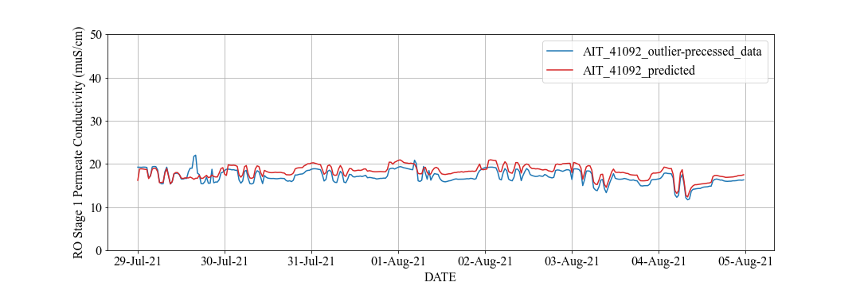

**(a): 1st Stage Permeate Conductivity**

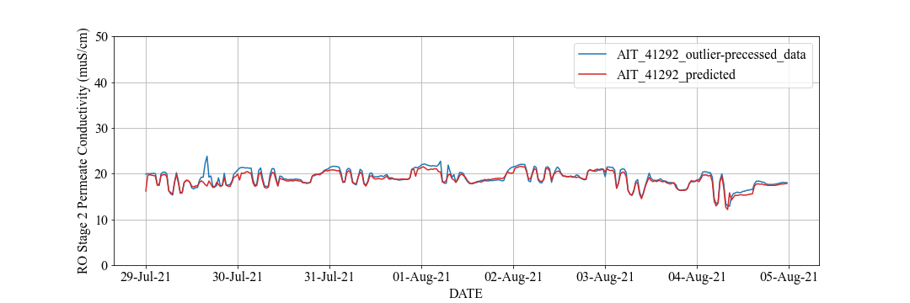

**(b): 2nd Stage Permeate Conductivity**

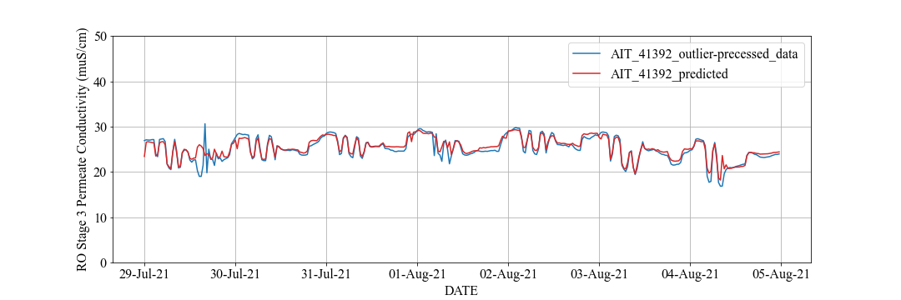

**(c): 3rd Stage Permeate Conductivity**

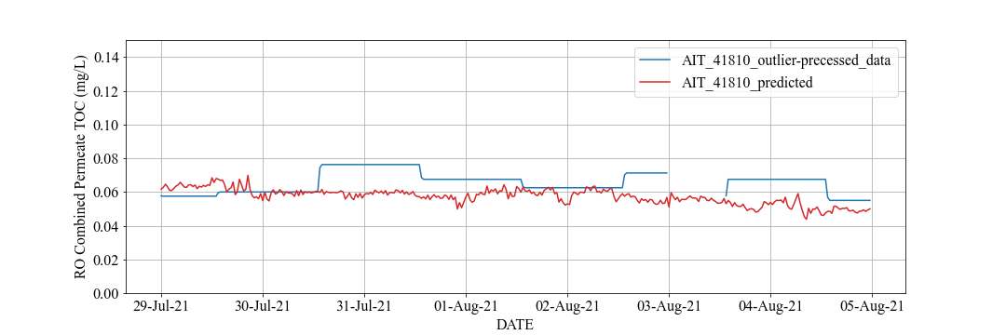

**(d): Permeate TOC**

**Figure 2.3: Prediction Trend from 29th July to 4th August 2021 (LVMWD)**

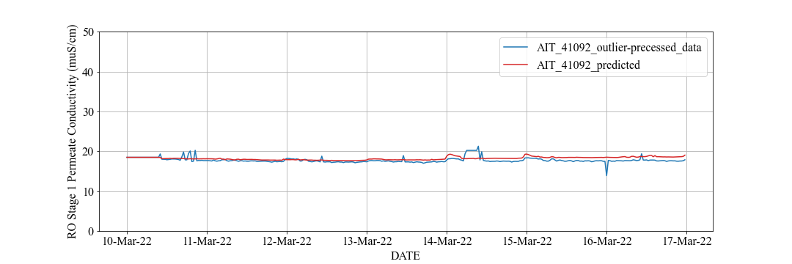

**(a): 1st Stage Permeate Conductivity**

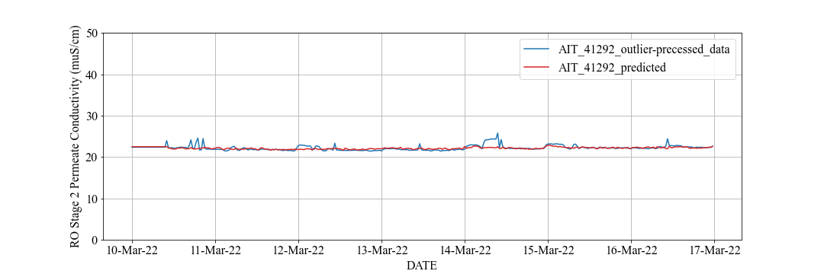

**(b): 2nd Stage Permeate Conductivity**

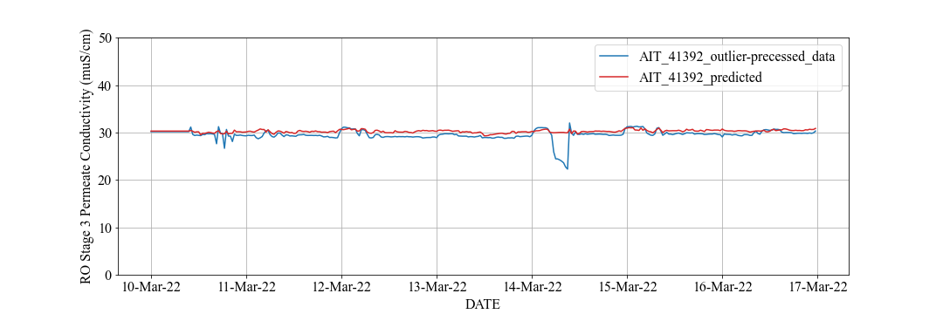

**(c): 3rd Stage Permeate Conductivity**

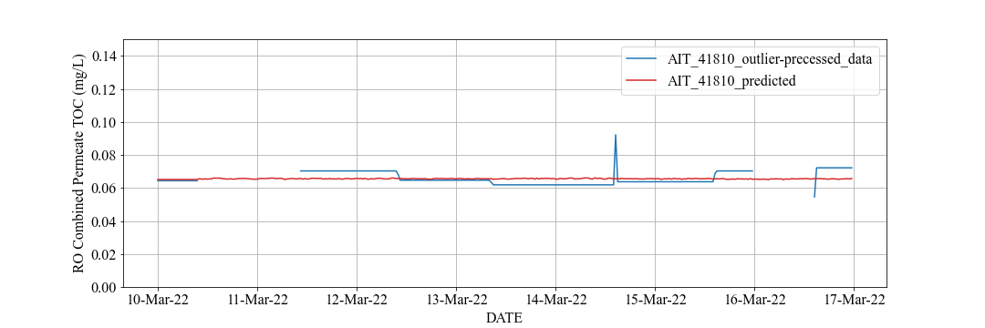

**(d): Permeate TOC**

**Figure 2.4: Prediction Trend from** **10th to 17th March 2022 (LVMWD)**

Figure 2.5 shows RO feed EC, RO feed TOC, and 3rd stage permeate EC actual data trend chart in the whole period. The gray region in Figure 2.5 coressponds to the gray region in Figure 2.2 and the orange region in Figure 2.5 (c) coressponds to the orange region in Figure 2.2 (c).

By comparing the gray regions in Figures 2.2 and 2.5, the significant fluctuation in the predicted RO permeate water quality is caused by the fluctuation in the RO feed actual data.

Moreover, the performance of 3rd stage peremate EC prediction deteriorates during the period in the orange region of Figure 2.2 (c). There is a significant change of 3rd stage permeate EC actual data in this period as shown in Figure 2.5 (c). The sequential prediction during this period is difficult since data characteristics differ significantly between training and prediction period.



**(a): Feed Conductivity (b): Feed TOC**



**(c): 3rd Stage Permeate Conductivity**

**Figure 2.5: Actual Data Trend in RO Feed (LVMWD)**

* Future Task

Measured data of permeate EC and TOC has large outliers frequently, but the current preprosessing method does not remove all of them. We will consider applying a new imputation method to these data and to consider sensor measurement accuracy.

The Kalman Filter[5] is an example of new imputation method and widely used in modern control thoery. The permeate TOC actual data corrected by the Kalman Filter is shown in Figure 2.6, where the blue line is TOC trend chart preprocessed by the method in the previous section and the orange line is TOC trend chart preprocessed by the Kalman Filter. Comparing the results, the Kalman Filter has better smoothing of data with large noise. This indicates that the new imputation method is effective for outlier correction.

The same issues regarding trends in optimization variables remain as with OCWD.

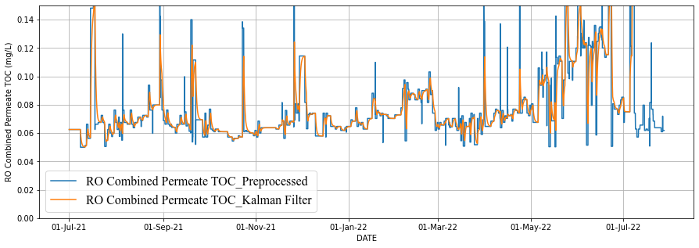

**Figure 2.6: Preprocessed Permeate TOC by Kalman Filter (LVMWD)**

#### RO Membrane Fouling

* Summary

There are several factors, such as fluidic and chemical loads, that cause fouling on RO membrane. For the former, higher flow rate or pressure place a greater load on the membrane. For the latter, higher concentration of substances in the feedwater places a greater load on the membrane. This report focuses on the fluidic load.

* Method to Estimate Energy Loss

To derive fluidic load on RO membranes, let $X_{i,j}$ be a measured data $X$ at each location and stage, and subscripts “ $i,j$” denotes RO stage number (1st, 2nd, 3rd stage) and locations (feed, permeate, and concentrate) and Figure 2.7 defines the inputs and outputs of an RO system.

Bernoulli’s principle, which can be seen as an energy conservation law in fluid dynamics, is used to estimate the fluidic load on RO membranes. Considering the fluidic load, the energy loss $R_{RO}$ due to the resistance of the membrane is described as the following equations: $$\begin{aligned}R_{RO}=c_{P}\left(P_{1,feed}-P_{perm}-P_{3,conc}\right)- \frac{ρ}{a^{2}}∙\frac{c_{v}^{2} }{2}\left(-{Q_{1,feed}}^{2}+{Q_{perm}}^{2}+{Q_{3,conc}}^{2}\right)\#\left(2.1\right)\end{aligned} \\ \begin{aligned}{Q_{perm}}^{2}={Q_{1,perm}}^{2}+{Q_{2,perm}}^{2}+{Q_{3,perm}}^{2}\#\left(2.2\right)\end{aligned}$$

$$\begin{aligned}P_{perm}=P_{1,perm}+P_{2,perm}+P_{3,perm}\#\left(2.3\right)\end{aligned}$$

, where $P\left[psi\right]$ is the static pressure, $Q\left[gpm\right]$ is the flow rate, $ρ\left[kg/m^{3}\right]$ is the density, $c_{P},c_{v}$ are unit conversion coefficients, $a[m^{2}]$ is the cross-sectional area of the pipe, respectively. Note that we tentatively assume that all the pipe diameters $a$ has the same diameter because we do not have the information on the diameters at each location. A detailed derivation of concentration polarization is provided as “Additional Materials A3” at the end of this report.

Considering that $R_{RO}$ is the energy loss at a membrane, it can be considered as a good explanatory factor to estimate the fouling of the membrane. As the fouling on the membrane progresses, the resistance at the membrane increases and the energy loss $R_{RO}$ increases. We can estimate the energy loss $R_{RO}$ after estimating unknown parameters $ρ/a^{2}$ in Equation (2.1).

* Results

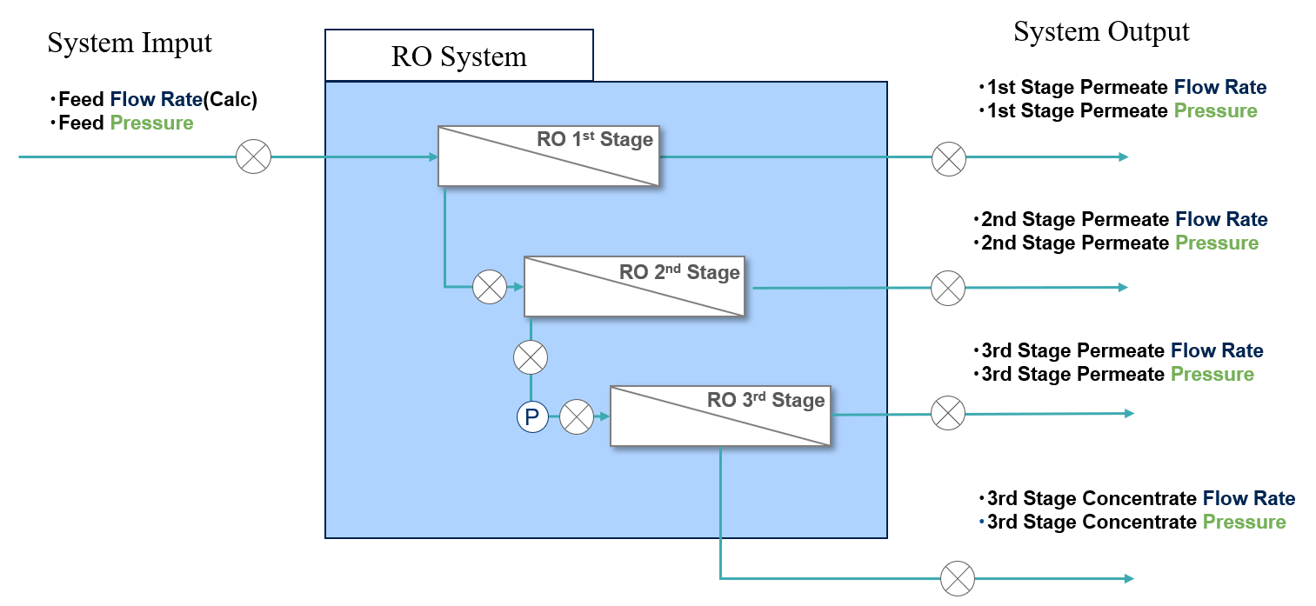

**Figure 2.7: Definition of Inputs/Outputs of RO System**

There are unknown parameters $ρ/a^{2}$ in Equation (2.1). To estimate it, we assumed $R_{RO}=0$ tentatively and solved $ρ/a^{2}$ by the least-squares method and obtained the result in Figure 2.8. Figure 2.8 (a) shows the result for LVMWD and (b) shows that for OCWD. In all plots, the vertical axis shows the feature values related to flow rates (the second term of Equation (2.1)) and the horizontal one shows those related to pressures (the first term of Equation (2.1)). In both cases of LVMWD and OCWD, we get positive regression coefficients, which is consistent with fluidic insights that density or density divided by squared area are positive.  
 Looking at the scatter plot of LVMWD, it has low correlation and the estimation of $ρ/a^{2}$ is not expected to be accurate. One of the reasons may be that we assumed the diameters of pipes are the same. In OCWD case, the accuracy is known to be improved by considering the diameters of pipes. Figure 2.8 (b) is calculated using pipe diameters described in P&ID and (c) is calculated without that information. Comparing them, (b) has positive correlation and coefficients, while (c) does not. We expect the estimation accuracy in LVMWD will also be improved if the diameters are known.   
 Finally, we calculated $R_{RO}$ using Equation (2.1) with estimated parameters. Figure 2.9 shows 0-1 normalized values of estimated $R_{RO}$ in the vertical axis and dates in the horizontal axis. The energy loss of the fluid is fluctuating according to the inputs. Derivation of an energy conservation law reflecting mass on the RO system output and consideration of booster pump dynamics are future works.

* Future Task

Future tasks are as the follows: (i) the estimation accuracy improvement if the diameters are known; (ii) construction of fouling model by using the feature $R_{RO}$ for optimization simulation.

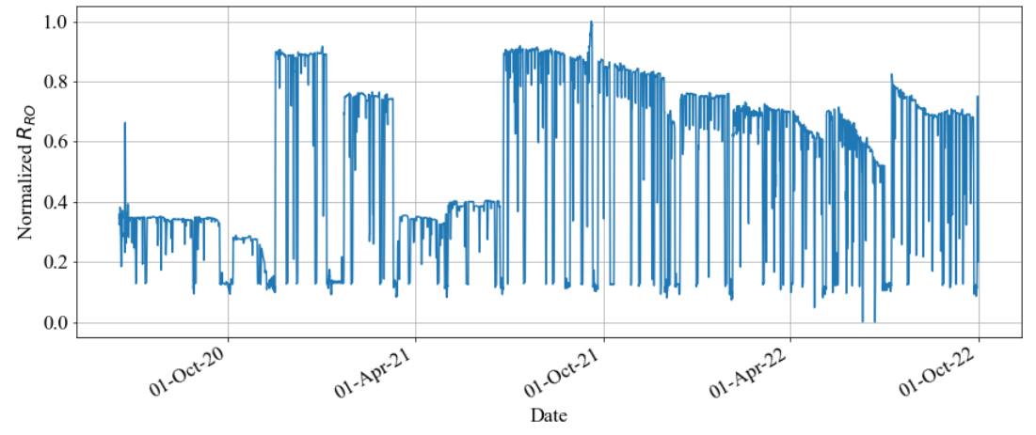

**Figure 2.9: Estimated $R_{RO}$**  **Trend Chart**

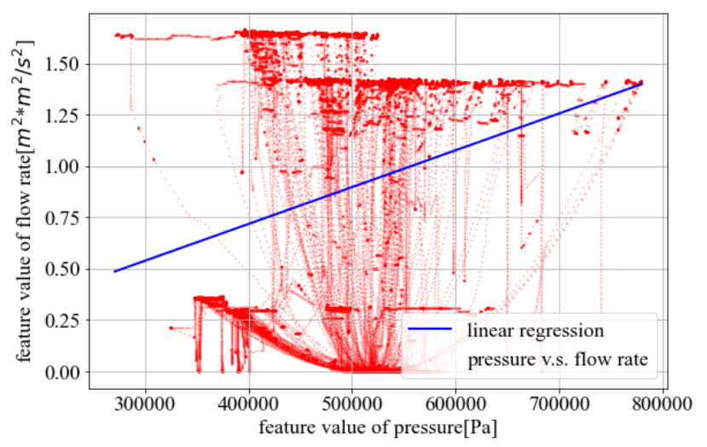  
**(a) $ρ/a^{2}$ Estimation Result (LVMWD Data)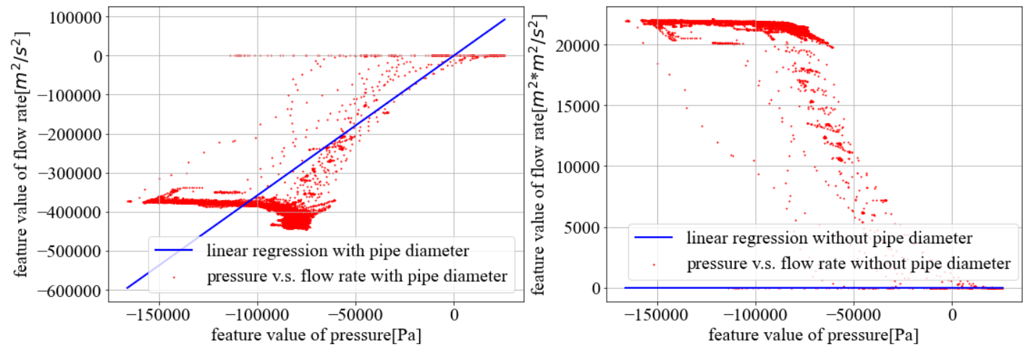 (b) $ρ$ Estimation Result (OCWD Data) (c) $ρ/a^{2}$ Estimation Result (OCWD Data)**

**Figure 2.8: Estimation Results of Unknown Parameters**

### Desktop Evaluation based on WBMWD

1. **Background and Objective**

WBMWD receives secondary effluent from the City of Los Angeles’s Hyperion Water Reclamation Plant (HWRP)[6].

As WBMWD process flow schematic is shown in Figure 3.1. The secondary effluent is distributed to two streams; 40 MGD recycled water for industrial and irrigation as highlighted in yellow in the Figure, and another 45 MGD recycled water for cooling tower and boiler feed as highlighted in gray in the Figure 3.1.

The objective of data analysis is to maintain effluent turbidity less than 2 NTU required by the Title 22 criteria and to optimize ferric chloride and cationic polymer dosage for saving.

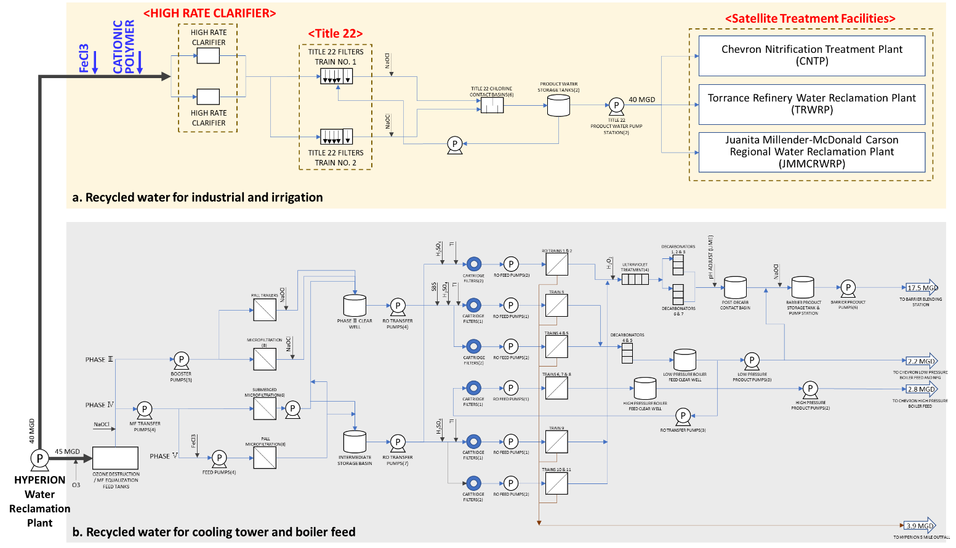

Figure 3.1: WBMWD Process Flow Schematic

1. **Material and Methods**

* Title 22 Requirements Consideration

Title 22 is California’s Code of Regulations which refers to the State guidelines for how treated and recycled water is discharged and used[7]. The water quality criteria for the four types of recycled water are defined by the Title 22 Code. In this data analysis, the criteria for turbidity should be considered and is defined as below[8].

* Criteria 1: Not exceed average turbidity of 2 NTU within a 24-hour period
* Criteria 2: Not exceed 5 NTU more than 5 percent of the time within a 24-hour period
* Criteria 3: Not exceed 10 NTU at any time

Considering Criteria 1, 2 and 3, daily average of Title 22 filter effluent turbidity, the number of times that turbidity exceeds 5 NTU and turbidity hourly average data were calculated with hourly data, respectively.

* Target Process for Data Analysis and Measurement Points
* Target Process

The secondary effluent from HWRP is received by WBMWD and the recycled water for industrial and irrigation sent to three Satellite Treatment Facilities (Chevron Nitrification Treatment Plant, Torrance Refinery Water Reclamation Plant, and Juanita Millender-McDonald Carson Regional Water Reclamation Plant)4 that have MF and RO membranes systems. “HIGH-RATE CLARIFIER” and “Title 22” filter behaviors indicated by red in Figure 3.1 were investigated to optimize ferric chloride (FeCL3) and cationic polymer dosage.

Title 22 is a set of regulations in the California Code of Regulations. There are two types of tertiary media filters, Tittle 22 filters and converted Title 22 filters. The converted Title 22 filters have an anthracite bed as deep as 4 to 6 feet4.

In this process, FeCL3 and cationic polymer are injected before the HIGH-RATE CLARIFIER to meet the Title 22 criteria. On the other hands, residual FeCL3 affects the following MF and RO membranes clogged at the Satellite Treatment Facilities. More FeCL3 dosing than the adequate demand doesn’t lead to the Title 22 filter performance in terms of turbidity control as expected. In this analysis, we focused on turbidity behaviors and residual FeCL3 from Title 22 filter.

* Measurement Points

To analyze data for Title 22 filter, both online hourly and grab sampling daily data listed in Table 3.1 were provided. The data from “1” to “12” are online data from January 2020 through March 2023, and the data from “G1” to “G3” are grab sampling daily data from September 2020 through March 2023.

The measurement points of the data received indicates in Figure 3.2. The online data from “1” to “12” are hourly recorded in the High-Rate Clarifier and Title 22 filter, and the grab sampling daily data from “G1” to “G3” are turbidity to confirm performance of the High-Rate Clarifier.

Table 3.1: Data List





Figure 3.2: Measurement Points

* Predicting Effluent Turbidity and Residual FeCL3 from Title 22 Filter

As a first step, we confirmed that effluent turbidity and residual FeCL3 from Title 22 filter could be predicted using both grab sampling daily and online hourly data by multiple regression analysis (MLR). They are MLR as in the case of OCWD and LVMWD model. The data were standardized. MLR and data standardization are provided as “Additional Materials A3” at the end of this report.

* Predicting Effluent Turbidity and Residual FeCL3 from Title 22 filter using Grab Sampling Daily Data

We calculated effluent turbidity and residual FeCL3 from Title 22 filter using grab sampling daily data by MLR.

As shown in Figure 3.2, influent turbidity to Title 22 filter was not measured as online but grab sampling. The grab sampling daily data cannot be incorporated into the prediction based on online hourly data. However, we predicted effluent turbidity and residual FeCL3 from Title 22 filter to confirm the relationships of turbidity between influent and effluent of Title 22 filter.

The variables to predict effluent turbidity and residual FeCL3 are listed in Table 3.2. The data “a” through “f” are explanatory variables, and the data “g” and “h” are objective variables. All of them are online data except for turbidity in Title 22 filter influent.

Regarding the variable “a” and “b”, these are calculated values by influent flow rate multiplied by chemicals (FeCL3 and Cationic Polymer) to secure the correlation with effluent turbidity and residual FeCL3.

Table 3.2: Variables to Predict Effluent Turbidity and Residual FeCL3



* Predicting Effluent Turbidity and Residual FeCL3 from Title 22 filter using Hourly Online Data

Effluent turbidity and residual FeCL3 from Title 22 filter were calculated using hourly online data by MLR.

The variables to predict effluent turbidity and residual FeCL3 are listed in Table 3.3. The data “a” through “f” are explanatory variables, and the data g and h are objective variables. All of them are online data.

Table 3.3: Variables to Predict Effluent Turbidity and Residual FeCL3



#### Results

* Trend Charts at Measurement Points

All online trends except for backwash clarifiers are illustrated in Figure 3.3 (a) to Figure 3.3 (i). Apparently different behaviors were observed in FeCL3 dosage, cationic polymer dosage, Title 22 filter effluent turbidity and other parameters from July to November 2021.

Over that period, suspended solids in secondary effluent from HWRP were carried over to WBMWD. It resulted in solids overloaded for the High-Rate Clarifier and Title 22 filter.

* Title 22 Filter Behaviors

The daily average data of effluent turbidity from Title 22 filter exceeded 2 NTU 282 times in 1186 days, as shown in Figure 3.4 (a), if classified the data based on the Criteria 1.

Figure 3.4 (b) shows the number of times that effluent turbidity exceeded 5 NTU in a day if the Criteria 2 considered. It exceeded 5 NTU more than 5% of the time (1.2 times in a day) 21 times in 1186 days.

Figure 3.4 (c) shows online hourly data of turbidity from Title 22 filter, which no data that exceeded 10 NTU at any time.

We will optimize FeCL3 and cationic polymer dosages to meet the Title 22 criteria considering the Criteria 1 and 2. The effluent turbidity is to maintain less than 2 NTU required by the Title 22 criteria.



(a): Ferric Chloride Dosage (b): PTHRC 1 Influent Flow Rate



(c): PTHRC 1 Cationic Polymer Dosage (d): PTHRC 2 Influent Flow Rate



(e): PTHRC 2 Cationic Polymer Dosage (f): PTHRC 2 Influent Flow Rate



(g): Title 22 Product Water Pressure (h): Title 22 Product Ferric Concentration



(i): Title 22 Filter Effluent Turbidity

Figure 3.3: Trend Charts for Each Data (WBMWD)



(a): [Title 22 Criteria 1] Turbidity Daily Average Data



(b): [Title 22 Criteria 2] The Number of Times that Turbidity Exceeds 5 NTU



(c): [Title 22 Criteria 3] Turbidity Hourly Average Data

Figure 3.4: Turbidity Trend Chart for Each Title 22 Criteria

* Predicting Effluent Turbidity and Residual FeCL3
* **Predicting Effluent Turbidity and Residual FeCL3 from Title 22 filter using Grab Sampling Daily Data**

Learning period is from May 10th, 2022, to March 7th, 2023, that corresponds to the statuses below.

* + The correlation between influent turbidity to Title 22 filter (Average of “G2” and “G3” in Figure 3.2) and effluent turbidity from Title 22 filter (“9” in Figure 3.2) is positive. The scatter plot of the turbidity both influent and effluent of Title 22 filter shown in Figure 3.5, and find the correlation positive (R=0.47).
  + The correlation between FeCL3 and Cationic Polymer dosage against effluent turbidity are negative are negative as shown in Figure 3.6 (a) and Figure 3.6 (b), these correlation coefficients -0.27 and -0.62 are given, respectively. The model accuracy was evaluated from Feb in 2022 to April in 2022 by root mean squared error (RMSE).



(a): Correlation between FeCL3 (b): Correlation between Cationic Polymer

and Effluent Turbidity from Title 22 and Effluent Turbidity from Title 22

Figure 3.6: Correlation between Chemicals and Effluent Turbidity from Title 22 (Daily)



Figure 3.5: Correlation between before / after Title 22 Turbidity

The model accuracy was evaluated from Dec. 1st, 2021, to Dec. 8th, 2021, by RMSE. Figure 3.7 shows prediction trend charts and accuracy of each prediction model. The yellow line is actual value, and the blue line is predicted value.

Figure 3.7 (a) shows the prediction results of Title 22 filter Ferric Concentration. As a result of prediction by the multiple regression analysis, the model accuracy of Title 22 filter Product Ferric Concentration during the evaluation period was RMSE = 0.44.

Figure 3.7 (b) shows the prediction results of the effluent turbidity. As a result of the prediction by the multiple regression analysis, the model accuracy of Title 22 filter effluent turbidity was RMSE = 0.43.



(a): Title 22 Product Ferric Concentration



(b): Title 22 Filter Effluent Turbidity

Figure 3.7: Prediction Model Accuracy using Grab Sampling Daily Data

* **Predicting Effluent Turbidity and Residual FeCL3 from Title 22 filter using Hourly Online Data**

Learning period is from April 27th, 2022, to May 7th, 2022, that corresponds to the status below.

* The correlation between FeCL3 and Cationic Polymer dosage against effluent turbidity is negative as shown in Figure 3.8 (a) and Figure 3.8 (b), these correlation coefficients -0.62 and -0.39 are given, respectively.

The model accuracy was evaluated from Dec. 1st, 2021, to Dec. 8th, 2021, by RMSE. Figure 3.9 shows prediction trend charts and accuracy of each prediction model. The yellow line is actual value and the blue line is predicted value.

Figure 3.9 (a) shows the actual value and the predicted value of Title 22 filter Ferric Concentration. As a result of prediction by the multiple regression analysis, the model accuracy of Title 22 filter Product Ferric Concentration during the evaluation period was RMSE = 0.11.

Figure 3.9 (b) shows the actual value and the predicted value of Title 22 filter effluent turbidity. As a result of prediction by multiple regression analysis, the model accuracy of Title 22 filter effluent turbidity during the evaluation period was RMSE = 0.40.



(a): Correlation between FeCL3 (b): Correlation between Cationic Polymer

and Effluent Turbidity from Title 22 and Effluent Turbidity from Title 22

Figure 3.8: Correlation between FeCL3 and Cationic Polymer against Effluent Turbidity from Title 22 filter (Hourly)



(a): Title 22 Product Ferric Concentration



(b): Title 22 Filter Effluent Turbidity

Figure 3.9: Prediction Model Accuracy using Hourly Online Data

### Future Tasks

In the model creation for OCWD and LVMWD, we will continue to consider the combination machine learning model and concentration polarization model for RO membrane system. And we will simulate if chemicals can be reduced while predicting water qualities such as conductivity, TOC, etc. and detecting membrane fouling and scaling.

In the model creation for WBMWD, we proceed to the simulation to optimize FeCL3 and cationic polymer dosages to secure the Title 22 requirements.

### Additional Materials

#### A1) RO System Configuration (OCWD, LVMWD)

* RO System Configuration of OCWD

The data set provided to this team is for the 100 mgd system. We note that the capacity has recently been upgraded to 130 mgd. The full-scale RO membrane system in OCWD, for the longer running 100 mgd of capacity, consists of 21 RO units (3 RO units x 7 RO trains) and each unit has 5 MGD capacity. As OCWD reported in Figure A.1**[9]**, these 21 RO systems are being operated by different types of RO membranes. Current analysis focuses upon RO UNIT B01. As shown in the figure below, the membrane type of RO UNIT B01 is Filmtec BW30XFRLE installed in October 2020.

RO UNIT B01 is a 3-stage configuration, with flow rate, pressure, conductivity, and differential pressure measured as shown in the Figure A.2. 50 categories of data were provided including feed & permeate flow rate, feed & permeate water qualities (such as conductivity, TOC, turbidity), feed & permeate pressure, Xact, and chemical dosage. Tag name list in OCWD is shown in Table A.1.

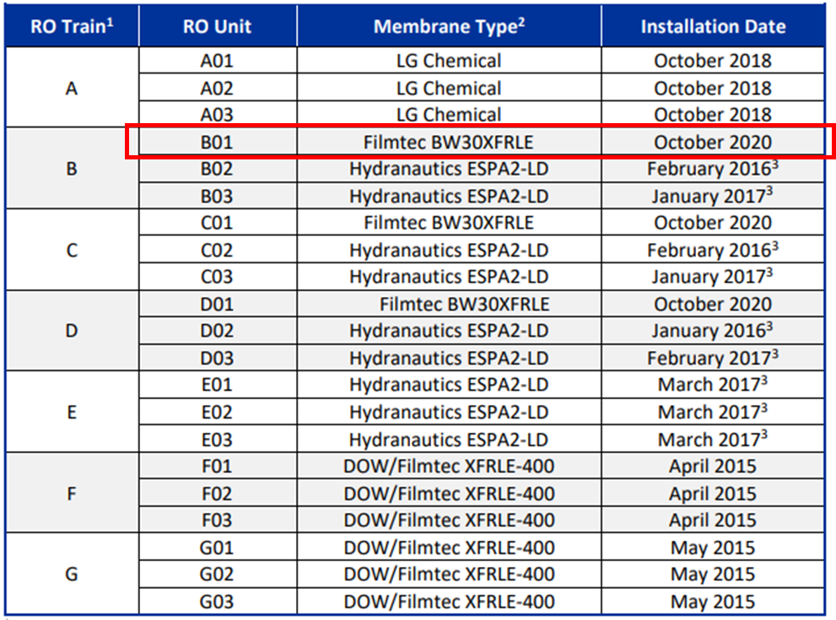

**Figure A.1: RO System Membranes (OCWD)**



**(a): The Whole RO System**



**(b): RO Unit B01 System**

**Figure A.2: RO System Configuration (OCWD)**

**Table A.1: Tag Name List (OCWD)**

|  |  |
| --- | --- |
| Tag Name | Variable Name |
| RO_B01 FW Press | RO B01 Feed Pressure |
| RO_Feed Cond | RO Feed EC |
| RO_01_FirstStageFeedFlow | RO Feed Flow Rate |
| RO_Feed Temperature | RO Feed Temperature |
| RO_Feed Ph | RO Feed pH |
| Sulfric Acid Usage | Sulfuric Acid Usage |
| Threshold Inhibitor Usage | Threshold Inhibitor Usage |
| RO_B01 FW B2 Press | RO B01 Feed Pressure |
| RO_01_SecondStageFeedConductivity | RO B01 Stage 2 Feed EC |
| RO_01_SecondStageFeedFlow | RO B01 Stage 2 Feed Flow Rate |
| RO_01_ThirdStageFeedConductivity | RO B01 Stage 3 Feed EC |
| RO_01_ThirdStageFeedFlow | RO B01 Stage 3 Feed Flow Rate |
| RO_Feed TOC | RO Feed TOC |
| RO_B01 Blank 1 Perm Cond | RO B01 Stage 1 Permeate EC |
| RO_B01 Blank 2 Perm Cond | RO B01 Stage 2 Permeate EC |
| RO_B01 Blank 3 Perm Cond | RO B01 Stage 3 Permeate EC |
| RO_Permeat TOC | RO Permeate TOC |

* RO System Configuration of OCWD

The RO membrane system in LVMWD is a pilot scale system. The RO system consists of 3-stage configuration, utilized the Toray TMG10D membrane, and is shown in the Figure A.3. Tag name list in LVMWD is shown in Table A.2.

**Table A.2: Tag Name List (LVMWD)**

|  |  |
| --- | --- |
| Tag Name | Variable Name |
| PT_41095 | RO Stage 1 Feed Pressure |
| AIT_40006 | RO Feed EC |
| RO_01_FirstStageFeedFlow | RO Feed Flow |
| TIT_40005 | RO Feed Temperature |
| AIT_40008 | RO Feed pH |
| AI_31094 | UF Filtrate Total Chlorine |
| RO_01_SecondStageFeedConductivity | RO Stage 2 Feed EC |
| RO_01_SecondStageFeedFlow | RO Stage 2 Feed Flow |
| PT_41347 | RO Stage 3 Feed Pressure |
| RO_01_ThirdStageFeedConductivity | RO Stage 3 Feed EC |
| RO_01_ThirdStageFeedFlow | RO Stage 3 Feed Flow |
| AIT_40010 | RO Feed TOC |
| AIT_41092 | RO Stage 1 Permeate EC |
| AIT_41292 | RO Stage 2 Permeate EC |
| AIT_41392 | RO Stage 3 Permeate EC |
| AIT_41810 | RO Combined Permeate TOC |



**Figure A.3: RO System Configuration and Measurement Points (LVMWD)**

#### A2) Mathematical Optimization Problem

A formulated RO optimization problem for OCWD and LVMWD is given as follows and the optimization variable list is given as Table 1.1 and Table 2.1.

Mathematical optimization problem is formulated as minimizing $f(x)$ such that constraints $g_{κ}\left(x\right)≤0$ ($κ=1,2,…,K$), where $x∈R^{N}$ denotes the optimization variable, $f:R^{N}→R$ denotes the objective function (cost function), $g_{κ}:R^{N}→R$ denote $K$ constraint functions, $R$ denotes the set of real numbers, $N$ denotes the number of total variables, respectively.

* Optimization Problem (OCWD)

The objective function $f$ is sum of the threshold inhibitor usage formulated as follows:

$$\begin{aligned}f(x) =\sum_{t=1}^{L}{(c_{1}x_{ID0000}\left[t\right]+c_{2}x_{ID0001}\left[t\right])}\#\left(A3.1\right)\end{aligned}$$

Here, $x_{ID0000}\left[t\right]$ denotes threshold inhibitor usage at time $t$, $x_{ID0001}\left[t\right]$ denotes the sulfuric acid usage at time $t$, $c_{1},c_{2}$ denotes cost coefficients, and $L$ denotes the length (step size) of optimization period, respectively.

Constraint conditions are as following:

$$\begin{aligned}0≤x_{ID0000}\left[t\right]≤12; t=1,2,…,L\#\left(A3.2\right)\end{aligned}$$

$$\begin{aligned}0≤x_{ID0001}\left[t\right]≤4; t=1,2,…,L\#\left(A3.3\right)\end{aligned}$$

$$\begin{aligned}10≤x_{ID1000}\left[t\right]≤95; t=1,2,…,L\#\left(A3.4\right)\end{aligned}$$

$$\begin{aligned}20≤x_{ID2001}\left[t\right]≤200; t=1,2,…,L\#\left(A3.5\right)\end{aligned}$$

$$\begin{aligned}60≤x_{ID3001}\left[t\right]≤350; t=1,2,…,L\#\left(A3.6\right)\end{aligned}$$

$$\begin{aligned}0≤x_{ID4000}\left[t\right]≤0.15; t=1,2,…,L\#\left(A3.7\right)\end{aligned}$$

$$\begin{aligned}-1≤x_{ID0000}\left[t\right]-x_{ID0000}\left[t+1\right]≤1; t=1,2,…,L-1\#\left(A3.8\right)\end{aligned}$$

$$\begin{aligned}-1≤x_{ID0001}\left[t\right]-x_{ID0001}\left[t+1\right]≤1; t=1,2,…,L-1\#\left(A3.9\right)\end{aligned}$$

$$\begin{aligned}1.5≤γ_{ID1000}\left[t\right]≤2.3; t=1,2,…,L\#\left(A3.10\right)\end{aligned}$$

$$\begin{aligned}1.5≤γ_{ID2001}\left[t\right]≤2.3; t=1,2,…,L\#\left(A3.11\right)\end{aligned}$$

$$\begin{aligned}1.5≤γ_{ID3001}\left[t\right]≤2.3; t=1,2,…,L\#\left(A3.12\right)\end{aligned}$$

$$\begin{aligned}1.5≤γ_{ID4000}\left[t\right]≤2.5; t=1,2,…,L\#\left(A3.13\right)\end{aligned}$$

Here, Equations from (A3.2) to (A3.17) denotes lower and upper limit, Equations (A3.8) and (A3.9) denotes fluctuation range limit, Equations from (A3.10) to (A3.13) denotes water quality standards limit based on LRV, respectively.

Intermediate variables $x_{ID1000}\left[t\right]$ (Stage1 permeate conductivity), $x_{ID2001}\left[t\right]$ (Stage2 permeate conductivity), $, x_{ID3001}\left[t\right]$ (Stage3 permeate conductivity), and $x_{ID4000}\left[t\right]$ (permeate TOC) are calculated by water quality prediction model as follows:

$$\begin{aligned}x_{ID1000}\left[t\right]=F_{ID1000}(x_{ID0000}\left[t\right],x_{ID0001}\left[t\right],x_{ID0002}\left[t\right],x_{ID0004}\left[t\right],x_{ID0005}\left[t\right], \\ x_{ID0100}\left[t\right], x_{ID0101}\left[t\right]); t=1,2,…,L\#\left(A3.14\right)\end{aligned}$$

$$\begin{aligned}x_{ID2001}\left[t\right]=F_{ID2001}(x_{ID0000}\left[t\right],x_{ID0001}\left[t\right],x_{ID0004}\left[t\right],x_{ID0200}\left[t\right],x_{ID0201}\left[t\right], \\ x_{ID2000}\left[t\right]); t=1,2,…,L\#\left(A3.15\right)\end{aligned}$$

$$\begin{aligned}x_{ID3001}\left[t\right]=F_{ID3001}\left(x_{ID0000}\left[t\right],x_{ID0001}\left[t\right],x_{ID0004}\left[t\right],x_{ID0300}\left[t\right],x_{ID3000}\left[t\right]\right); \\ t=1,2,…,L\#\left(A3.16\right)\end{aligned}$$

$$\begin{aligned}x_{ID4000}\left[t\right]=F_{ID4000}(x_{ID0000}\left[t\right],x_{ID0001}\left[t\right],x_{ID0002}\left[t\right], x_{ID0003}\left[t\right],x_{ID0004}\left[t\right], \\ x_{ID0005}\left[t\right],x_{ID0100}\left[t\right], x_{ID0101}\left[t\right], x_{ID0200}\left[t\right]); t=1,2,…,L\#\left(A3.17\right)\end{aligned}$$

Here, a detail of each prediction model is provided in main section.

$γ_{X}$ is Logarithmic Reduction Value (LRV) of water quality data $X$ (e.g., electric conductivity and TOC) as follows:

$$\begin{aligned}γ_{X}\left[t\right]=\log_{10}\left(\frac{X_{feed}[t]}{X_{perm}[t]}\right); t=1,2,…,L\#\left(A3.18\right)\end{aligned}$$

Here, $X_{feed}$ denotes feed quality data $X$ and $X_{perm}$ denotes permeate quality data $X$ at each stage.

* Optimization Problem (LVMWD)

The objective function $f(x)$ is formulated as follows:

$$\begin{aligned}f(x) =\sum_{t=1}^{L}{(c_{1}x_{ID0000}\left[t\right])}\#\left(A3.19\right)\end{aligned}$$

Here, $x_{ID0000}\left[t\right]$ denotes UF filtrate total chlorine at time $t$, $c_{1}$ denote cost coefficients, and $L$ denotes the length (step size) of optimization period, respectively.

Constraint conditions are as following:

$$\begin{aligned}1≤x_{ID0000}\left[t\right]≤2; t=1,2,…,L\#\left(A3.20\right)\end{aligned}$$

$$\begin{aligned}0≤x_{ID1000}\left[t\right]≤50; t=1,2,…,L\#\left(A3.21\right)\end{aligned}$$

$$\begin{aligned}0≤x_{ID2001}\left[t\right]≤50; t=1,2,…,L\#\left(A3.22\right)\end{aligned}$$

$$\begin{aligned}0≤x_{ID3001}\left[t\right]≤60; t=1,2,…,L\#\left(A3.23\right)\end{aligned}$$

$$\begin{aligned}0≤x_{ID4000}\left[t\right]≤0.15; t=1,2,…,L\#\left(A3.24\right)\end{aligned}$$

$$\begin{aligned}-1≤x_{ID0000}\left[t\right]-x_{ID0000}\left[t+1\right]≤1; t=1,2,…,L-1\#\left(A3.25\right)\end{aligned}$$

$$\begin{aligned}1≤γ_{ID1000}\left[t\right]≤2.5; t=1,2,…,L\#\left(A3.26\right)\end{aligned}$$

$$\begin{aligned}1≤γ_{ID2001}\left[t\right]≤2.5; t=1,2,…,L\#\left(A3.27\right)\end{aligned}$$

$$\begin{aligned}1≤γ_{ID3001}\left[t\right]≤2.5; t=1,2,…,L\#\left(A3.28\right)\end{aligned}$$

$$\begin{aligned}1≤γ_{ID4000}\left[t\right]≤2; t=1,2,…,L\#\left(A3.29\right)\end{aligned}$$

Here, Equations from (A3.20) to (A3.24) denote lower and upper limit, Equation (A3.25) denotes fluctuation range limit, Equations from (A3.26) to (A3.29) denote water quality standards limit based on LRV, respectively. $γ_{X}$ is Logarithmic Reduction Value (LRV) of water quality data $X$ (e.g., electric conductivity and TOC).

Intermediate variables $x_{ID1000}\left[t\right]$ (Stage1 permeate EC), $x_{ID2001}\left[t\right]$ (Stage2 permeate EC), $, x_{ID3001}\left[t\right]$ (Stage3 permeate EC), and $x_{ID4000}\left[t\right]$ (permeate TOC) are calculated by water quality prediction model as follows:

$$\begin{aligned}x_{ID1000}\left[t\right]=F_{ID1000}\left(x_{ID0000}\left[t\right],x_{ID0001}\left[t\right],x_{ID0003}\left[t\right],x_{ID0004}\left[t\right],x_{ID0100}\left[t\right],x_{ID0101}\left[t\right]\right); \\ t=1,2,…,L\#\left(A3.30\right)\end{aligned}$$

$$\begin{aligned}x_{ID2001}\left[t\right]=F_{ID2001}(x_{ID0000}\left[t\right], x_{ID0003}\left[t\right],x_{ID0200}\left[t\right],x_{ID2000}\left[t\right]); t=1,2,…,L\#\left(A3.31\right)\end{aligned}$$

$$\begin{aligned}x_{ID3001}\left[t\right]=F_{ID3001}\left(x_{ID0000}\left[t\right], x_{ID0003}\left[t\right],x_{ID0300}\left[t\right],x_{ID0301}\left[t\right],x_{ID3000}\left[t\right]\right); \\ t=1,2,…,L\#\left(A3.32\right)\end{aligned}$$

$$\begin{aligned}x_{ID4000}\left[t\right]=F_{ID4000}(x_{ID0000}\left[t\right],x_{ID0001}\left[t\right],x_{ID0002}\left[t\right], x_{ID0003}\left[t\right],x_{ID0004}\left[t\right],x_{ID0100}\left[t\right], \\ x_{ID0101}\left[t\right],x_{ID0300}\left[t\right]); t=1,2,…,L\#\left(A3.33\right)\end{aligned}$$

Here, a detail of each prediction model is provided in main section.

#### A3) Mathematical Equations

Used mathematical equations for data analysis in this report are as follows:

* Multiple Linear Regression Model

Let $X={\left(x^{1},x^{2},…,x^{N}\right)}^{T}$ be the design matrix, $x^{i}={\left(x_{1}^{i},x_{2}^{i},…,x_{M}^{i}\right)}^{T}$ be the $i$-th explanatory vector, $y={\left(y^{1},y^{2},…,y^{N}\right)}^{T}$ be the predictive vector, and $(x^{i},y^{i})$ be the $i$-th training dataset.

In Multiple Linear Regression (MLR), the estimated parameters $\hat{w}={\left(\hat{w_{1}}, \hat{w_{2}},…,\hat{w_{M}}\right)}^{T}$ and $\hat{w_{0}}$ are shown as follows:

$$\begin{aligned}\hat{w}={\left(X^{T}X\right)}^{-1}X^{T}y\#\left(A4.1\right)\end{aligned}$$

$$\begin{aligned}\hat{w_{0}}=\overline{y}-(\hat{w_{1}}\overline{x_{1}}+\hat{w_{2}}\overline{x_{2}}+…+\hat{w_{M}}\overline{x_{M}})\#\left(A4.2\right)\end{aligned}$$

The standard coefficient ${\hat{w}}_{standard, j}$ is calculated by using the following equation:

$$\begin{aligned}{\hat{w}}_{standard, j}={\hat{w}}_{j}×\frac{std(x_{j})}{std(y)};j=1,2,…,M\#\left(A4.3\right)\end{aligned}$$

Here, $\overline{x_{j}},\overline{y}$ denote the average of $x_{j}^{i},y^{i}$ and $std\left(x_{j}\right),std\left(y\right)$ denote the standard deviation of $x_{j}^{i},y^{i}$, and they are calculated by using training dataset.

Moreover, the standardization of observation data $X$ is calculated by using the following equation:

$$\begin{aligned}X_{stand}\text{ = }\frac{X-\overline{X}}{std\left(X\right)}\#\left(A4.4\right)\end{aligned}$$

Here, $\overline{X}$ denote the average of $X$ and $std\left(X\right)$ denote the standard deviation of $X$.

* Prediction Evaluation Index

The prediction evaluation indexes are Mean Absolute Percentage Error (MAPE) $E_{MAPE}$ [%] and Root Mean Percentage Error (RMSE) $E_{RMSE}$. MAPE indicates a relative prediction error and RMSE is an absolute prediction error. They are formulated as follows: $$\begin{aligned}E_{MAPE}=\frac{100}{L}\sum_{t=1}^{L}{\frac{\left|y_{Pre}\left[t\right]-y_{Act}\left[t\right]\right|}{y_{Act}\left[t\right]}} [\%]\#\left(A4.5\right)\end{aligned} \\ \begin{aligned}E_{RMSE}=\sqrt{\frac{1}{L}\sum_{t=1}^{L}{{\left(y_{Pre}\left[t\right]-y_{Act}\left[t\right]\right)}^{2}}}\#\left(A4.6\right)\end{aligned}$$ 
Here, $y_{Act}\left[t\right]$ is the actual data and $y_{Pre}\left[t\right]$ is the predicted data at time $t$. $L$ is the length of the prediction period.

* Method to Calculate Concentration Polarization

Concentration polarization is calculated in the following steps.

* + Calculate osmotic pressure across a membrane
  + Calculate permeate flux from driving and osmotic pressures
  + Calculate mass transfer coefficient from osmotic pressure and permeate flux
  + Calculate concentration at the surface from mass transfer coefficient and feed/permeate concentration

First, osmotic pressure is calculated. Van’t Hoff equation holds between osmotic pressure $π_{i,j,m}$ and concentration $C_{i,j,m}$ as shown in the following equation:

$$\begin{aligned}π_{i,j,m}=C_{i,j,m}RT\#\left(A4.7\right)\end{aligned}$$

, where $R$ is the gas constant, $T$ is the temperature, and subscripts “ $i,j,m$” denotes RO stage number, locations (feed, membrane surface, permeate, brine), and solutes respectively.

We need know $π_{i,j,m}$ for each location “ $j$”, but some values to calculate them are not measured online. For example, concentration at the membrane surface and concentration of 2nd stage feed and brine are not available. Thus, we assumed the following for those values.

* The concentration at the surface of membrane is the same with that of the feed (as a tentative value during the calculation).
* The concentration of the feed to $i$-th stage is the same with that of the brine from $(i-1)$-th stage.
* The concentration of the feed to the 1st stage and those of the permeate from all stages are measured by Xact.

Next, permeate flux is calculated. The fluxes of solvent ${J_{v}}_{solv_{i}}$ and solutes ${J_{v}}_{salt_{i,m}}$ are calculated by Equations (A4.8) and (A4.9), respectively. $$\begin{aligned}{J_{v}}_{solv_{i}}=k_{w}×∆P_{trans, i}\#\left(A4.8\right)\end{aligned}$$

$$\begin{aligned}{J_{v}}_{salt_{i,m}}=k_{w}×\left\{∆P_{trans, i}-\left(π_{i,memb,m}-π_{i,brine,m}\right)\right\}\#\left(A4.9\right)\end{aligned}$$

$$\begin{aligned}∆P_{trans, i}=P_{i, feed}-P_{i, perm}\#\left(A4.10\right)\end{aligned}$$

, where $k_{w}$ is the permeability coefficient of pure water, $P_{i, feed},P_{i, perm}$ denote the static pressure at feed and permeate in $i$-th stage.

The mass transfer coefficients $k_{i,m}$ are calculated by the following equations:

$$\begin{aligned}k_{i,m}=\frac{{J_{v}}_{salt_{i,m}}}{\ln\left(\frac{∆P_{trans, i}}{π_{i,brine,m}-π_{i,perm,m}}×\left(1-\frac{{J_{v}}_{salt_{i,m}}}{{J_{v}}_{solv_{i}}}\right)\right)}\#\left(A4.11\right)\end{aligned}$$

The electric conductivities ${EC}_{i,brine}$ at unmeasured points are calculated by the following equation: $$\begin{aligned}{EC}_{i,brine}= \frac{Q_{i,feed} ×{EC}_{i,feed}-Q_{i,perm}×{EC}_{i,perm}}{Q_{i,feed} -Q_{i,perm}};i=1,2,3\#\left(A4.12\right)\end{aligned}$$ 
Here, $Q_{i,feed},Q_{i,perm}$ is feed and permeate flow rate at $i$-th stage. The concentration at membrane surface is calculated by the above equations.

* Method to Calculate Energy Loss due to RO Membrane

Bernoulli’s principle, which can be seen as an energy conservation law in fluid dynamics, is used to estimate the fluidic load on RO membranes. The law assumes the laminar flow conditions, the viscous resistance is negligible, the flow is incompressible and described as the following equation: $$\begin{aligned}P+\frac{1}{2}ρv^{2}+ρgh=const.\#\left(A4.13\right)\end{aligned}$$

, where $P\left[Pa\right]$ is the static pressure, $ρ\left[kg/m^{3}\right]$ is the density, $v\left[m/s\right]$ is the flow speed, $h\left[m\right]$ is the elevation, and $g\left[m/s^{2}\right]$ is the gravitational constant, especially the second term in the left side in Equation (2.1) is called the dynamic pressure $q=ρv^{2}/2[Pa]$.

Assuming the elevation of the pipes are the same, Equation (A4.13) can be transformed as the following equations: $$\begin{aligned}P_{feed}+\frac{1}{2}ρv_{feed}^{2}=P_{perm}+P_{3,conc}+q_{perm}+\frac{1}{2}ρv_{3,conc}^{2}\#\left(A4.14\right)\end{aligned}$$

$$\begin{aligned}P_{perm}=P_{1,perm}+P_{2,perm}+P_{3,perm}\#\left(A4.15\right)\end{aligned} \\ \begin{aligned}q_{perm}=\frac{1}{2}ρv_{1,perm}^{2}+\frac{1}{2}ρv_{2,perm}^{2}+\frac{1}{2}ρv_{3,perm}^{2}\#\left(A4.16\right)\end{aligned}$$

Here, $P_{perm}$ denotes RO total permeate static pressure and $q_{perm}$ denotes RO total permeate dynamic pressure $q_{perm}$, and they are sum of each stage permeate value, respectively. In an actual RO system, however, Equation (A.4.14) does not hold because the energy is lost due to the resistance of the membrane. By introducing energy loss due to membrane, denoted by $R_{RO}$, into Equation (A4.14), we have an energy conservation equation across a membrane as Equation (A4.17). $$\begin{aligned}P_{feed}+\frac{1}{2}ρv_{feed}^{2}=P_{perm}+P_{3,conc}+q_{perm}+\frac{1}{2}ρv_{3,conc}^{2}+R_{RO}\#\left(A4.17\right)\end{aligned}$$

Some units of the measured input/output variables should be converted so that we can calculate it. Conversion of static pressure and flow rate are explained below for an example. In this example, the measured static pressure is denoted by $P$ [psi] and the measured flow rate is denoted by $Q$ [gpm]. The static pressure and flow speed are in Equation (A4.17) is given by Equations (A4.18) and (A4.19). $$\begin{aligned}P_{i,j}\left[Pa\right]=c_{P}×P_{i,j}\left[psi\right]\#\left(A4.18\right)\end{aligned}$$

$$\begin{aligned}v_{i,j}\left[m/s\right]=c_{v}×\frac{Q_{i,j}\left[gpm\right]}{a_{i,j}\left[m^{2}\right]} \#\left(A4.19\right)\end{aligned}$$

, where $c_{P}=6895,c_{v}=3.7854/(60×1000)$ are unit conversion coefficients, $a[m^{2}]$ is the cross-sectional area of the pipe, subscripts “ $i,j$” denotes RO stage number, locations (permeate, concentrate), respectively. Moreover, we replace Equation (A4.19) with Equation (A4.20) if we tentatively assume that all of them has the same diameter $a$.

$$\begin{aligned}v_{i,j}\left[m/s\right]=c_{v}×\frac{Q_{i,j}\left[gpm\right]}{a\left[m^{2}\right]} \#\left(A4.20\right)\end{aligned}$$

1. R. Tanabe and A. Fukunaga: “Success-History Based Parameter Adaptation for Differential Evolution,” Proceedings of IEEE Congress on Evolutionary Computation 2013, pp.71–78 (2013)
2. K. Deb: “An Efficient Constraint Handling Method for Genetic Algorithms”, Computer Methods in Applied Mechanics and Engineering, Vol. 186 No. 2-4, pp.311-338 (2000)
3. The Black-box Optimization Benchmarking (BBOB) workshop (https://numbbo.github.io/workshops/)
4. <https://wwwbrr.cr.usgs.gov/projects/GWC_chemtherm/software.htm>
5. G. Welch and G. Bishop: “An Introduction to the Kalman Filter”, Univ. of North Carolina (1995)  
   https://perso.crans.org/club-krobot/doc/kalman.pdf
6. Recycled Water Master Plan West Basin Municipal Water District ([West-Basin-Master-Plan_final_rev4.pdf (westbasin.org)](https://www.westbasin.org/wp-content/uploads/2022/05/West-Basin-Master-Plan_final_rev4.pdf))
7. WATER EDDUCATION FOUNDATION, WATER RECYCLING AND TITLE 22 (https://www.watereducation.org/aquapedia/water-recycling-and-title-22#:~:text=Title%2022%20of%20California's%20Code,water%20is%20discharged%20and%20used.)
8. Wastewater Treatment Plant Master Plan, APPENDIX D: TITLE 22 REQUIREMENTS (https://www.napasan.com/DocumentCenter/View/276/Appendix-D-Title-22-Requirements-PDF)
9. GWRS 2020 ANNUAL REPORT (https://www.ocwd.com/wp-content/uploads/2020-gwrs-annual-report-appendices-1.pdf)